## **Module 3 Activity 3: Middleware**

Saurabh Kale

IFT 458/554: Middleware Programming & Database Security

Dinesh Sthapit

Sep 24th, 2023

**Part A-**

**Hello World-**

**App.js-**

// require express use or import express

const express = require('express');

const app = express();

app.get('/', (req, res) => {

    res.send('Hello World');

});

app.listen(3000, () => {

    console.log('Server is running on port 3000');

});

**Code-**

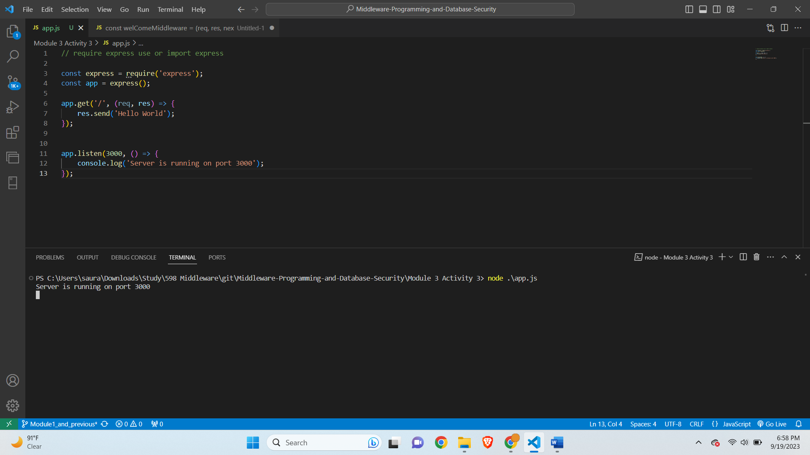

**Output-**

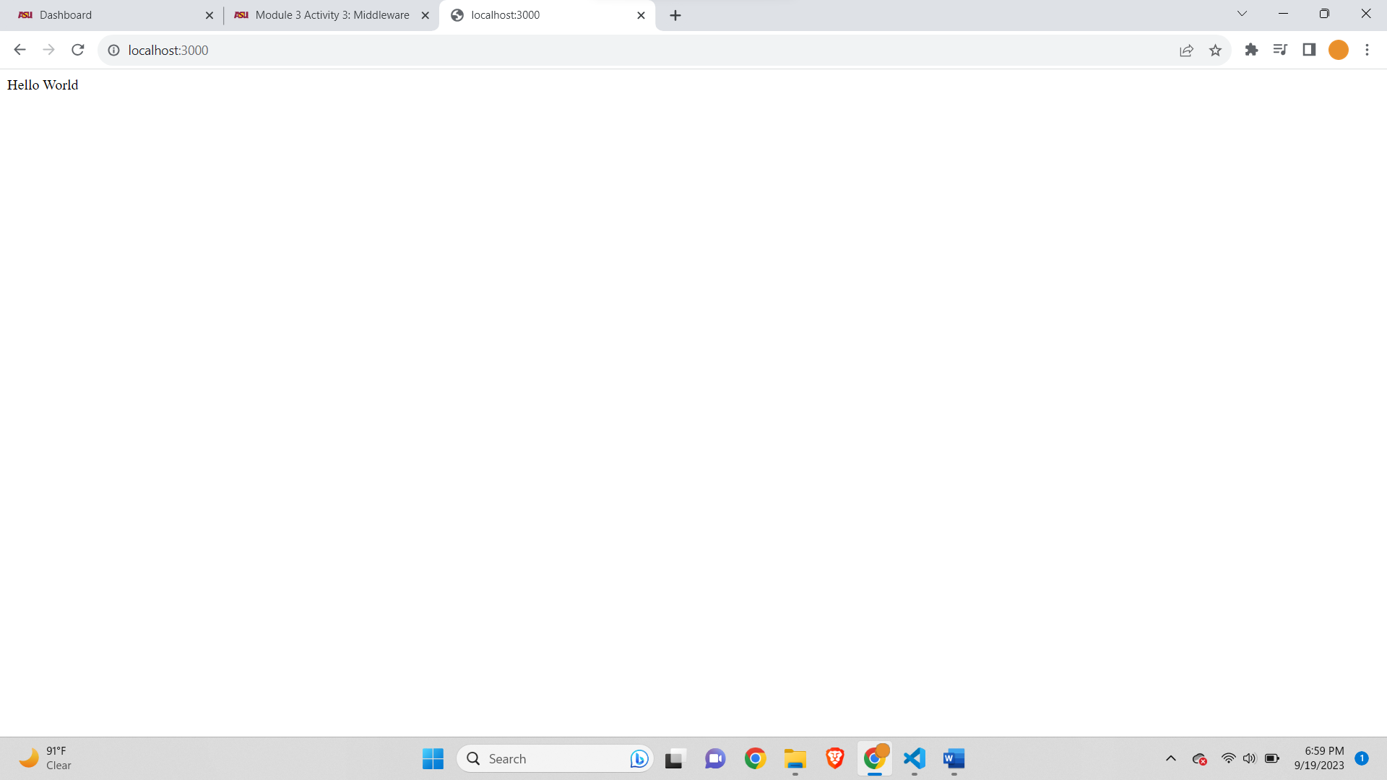

**WelcomeMiddleware Function-**

**App.js-**

// Name: Saurabh Kale

// ASUID: 1223450319

// Date: 9/24/2023

// require express use or import express

const express = require('express');

const app = express();

app.get('/', (req, res) => {

    res.send('Hello World');

});

const welComeMiddleware = (req, res, next) => {

    console.log('Welcome to my website');

    next();

}

app.use(welComeMiddleware);

app.listen(3000, () => {

    console.log('Server is running on port 3000');

});

**Code Screenshot-**

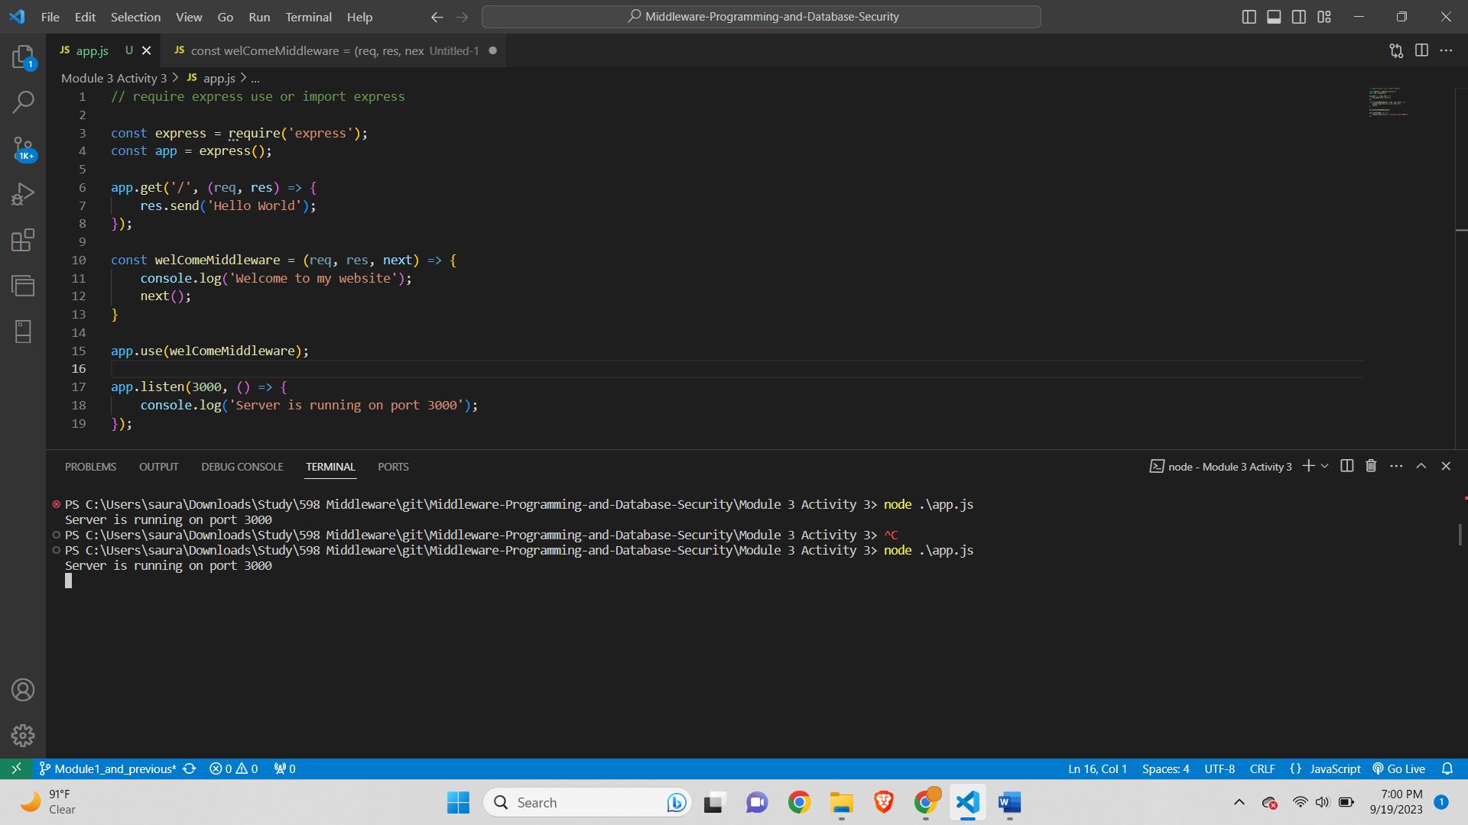

**Output Screenshot-**

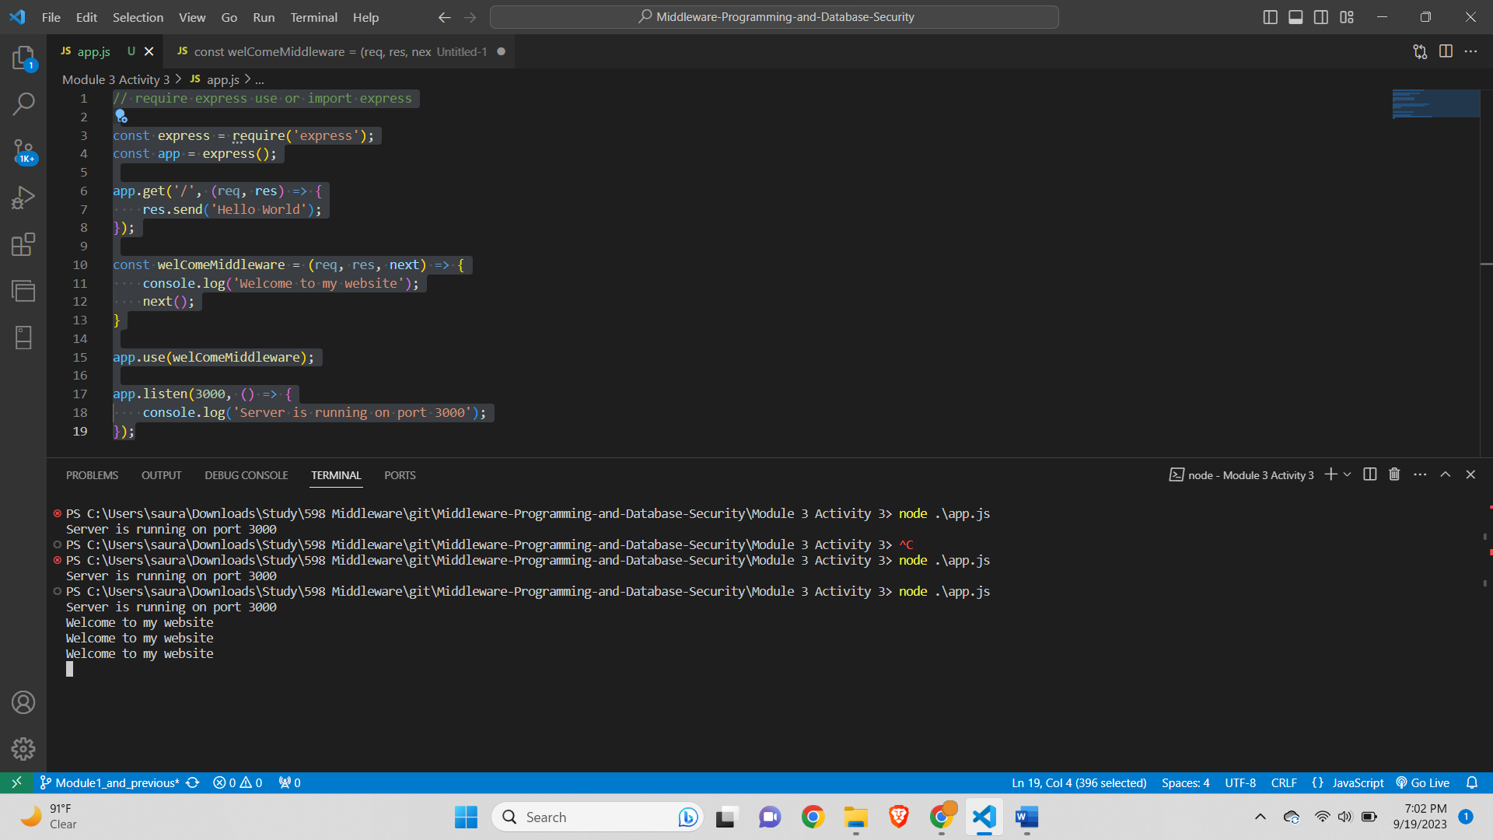

**CheckAdmin-**

**App.js-**

// Name: Saurabh Kale

// ASUID: 1223450319

// Date: 9/24/2023

// require express use or import express

const express = require('express');

const app = express();

const welComeMiddleware = (req, res, next) => {

    console.log('Welcome to my website');

    next();

}

const checkAdmin = (req, res, next) => {

    if(req.query.admin === 'true'){

        next();

    } else{

        res.status(400).send('Should be admin');

    }

}

app.use(welComeMiddleware);

app.use(checkAdmin);

app.get('/', (req, res) => {

    res.send('Hello World');

});

app.listen(3000, () => {

    console.log('Server is running on port 3000');

});

**Code Screenshot-**

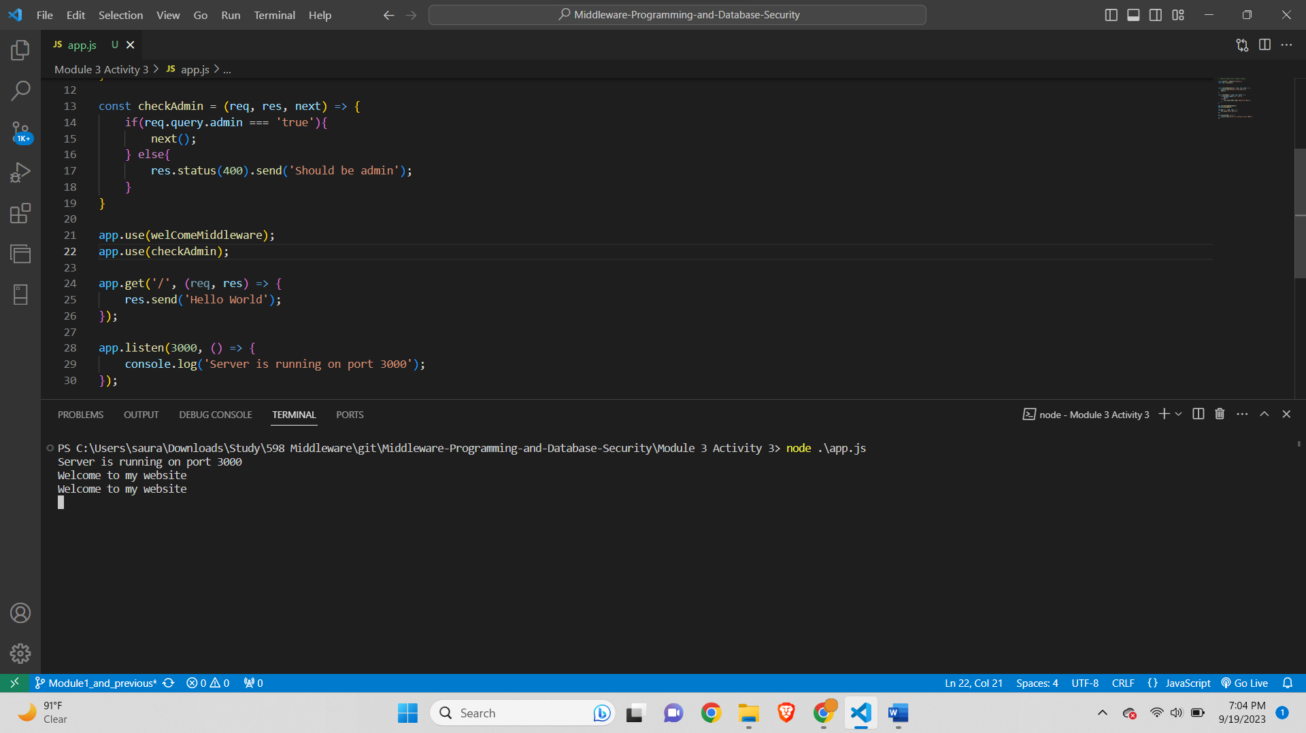

**Output Screenshot-**

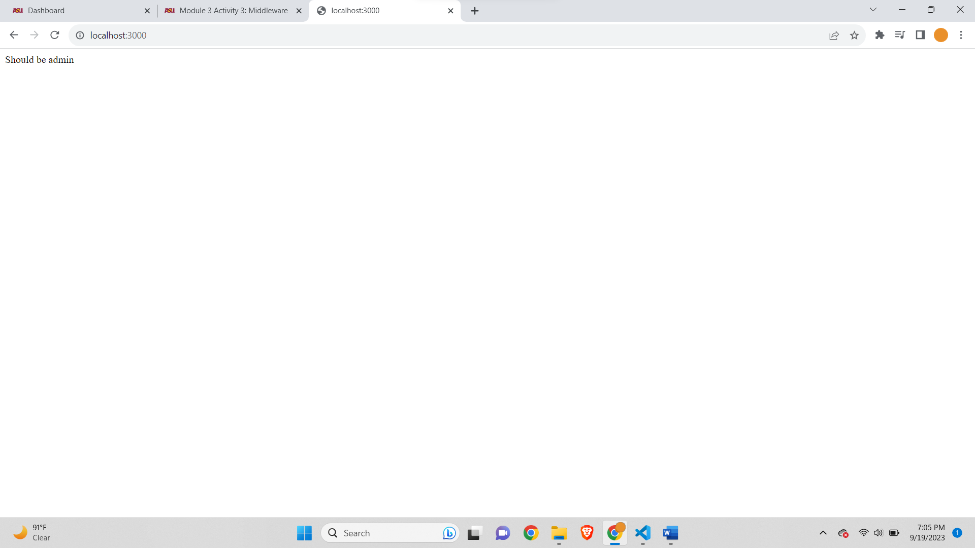

**Part A Debugging-**

**App.js-**

// Name: Saurabh Kale

// ASUID: 1223450319

// Date: 9/24/2023

// require express use or import express

const express = require('express');

const app = express();

const students = []; // array of students objects acting as storage

const bodyParser = require('body-parser');

app.use(bodyParser.json());

const getSpecificStudent = (req, res) => {

    const id = req.params.id;

    const currentStudent = students[id]

    res.send(`Student with the ${id} is ${currentStudent.fname} ${currentStudent.mname} ${currentStudent.lname}`);

}

const getStudents = (req, res) => {

    res.send(students);

}

const addStudent = (req, res) => {

    const student = req.body;

    students.push(student);

    res.send(`Student with the name ${student.fname} ${student.mname} ${student.lname} added to the database`);

}

const updateStudent = (req, res) => {

    const id = req.params.id;

    const student = req.body;

    students[id] = student;

    res.send(`Student with the id ${id} has been updated`);

}

const deleteStudent = (req, res) => {

    const id = req.params.id;

    const student = students[id];

    student.splice(id, 1);

    res.send(`Student with the id ${id} has been deleted`);

}

//  routes handlers CRUD interfaces

//  for every request, we have a response

app.get('/students/:id', getSpecificStudent); // get all students functions

app.get('/students', getStudents); // get all students functions

app.post('/students', addStudent); // add student function

app.put('/students/:id', updateStudent); //update student function

app.delete('/students/:id', deleteStudent); //delete student function

app.use('/', function(req, res, next) {

    console.log('Request Url:' + req.url);

    res.send('Hello');

});

app.listen(3000, () => {

    console.log('Server is running on port 3000');

});

**Debug for GET students-**

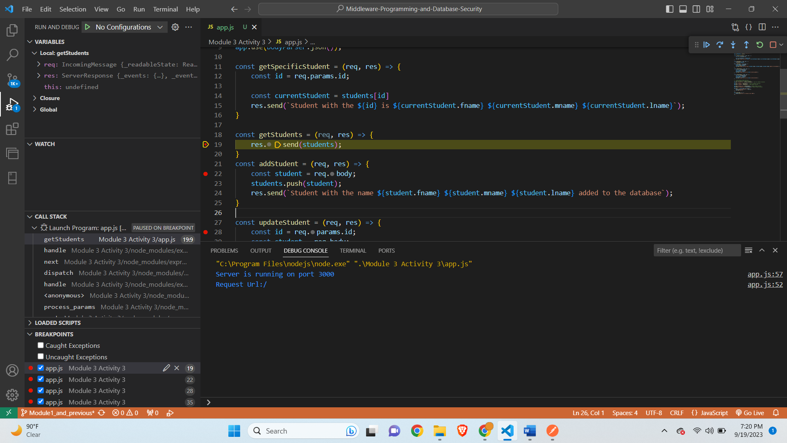

**Postman-**

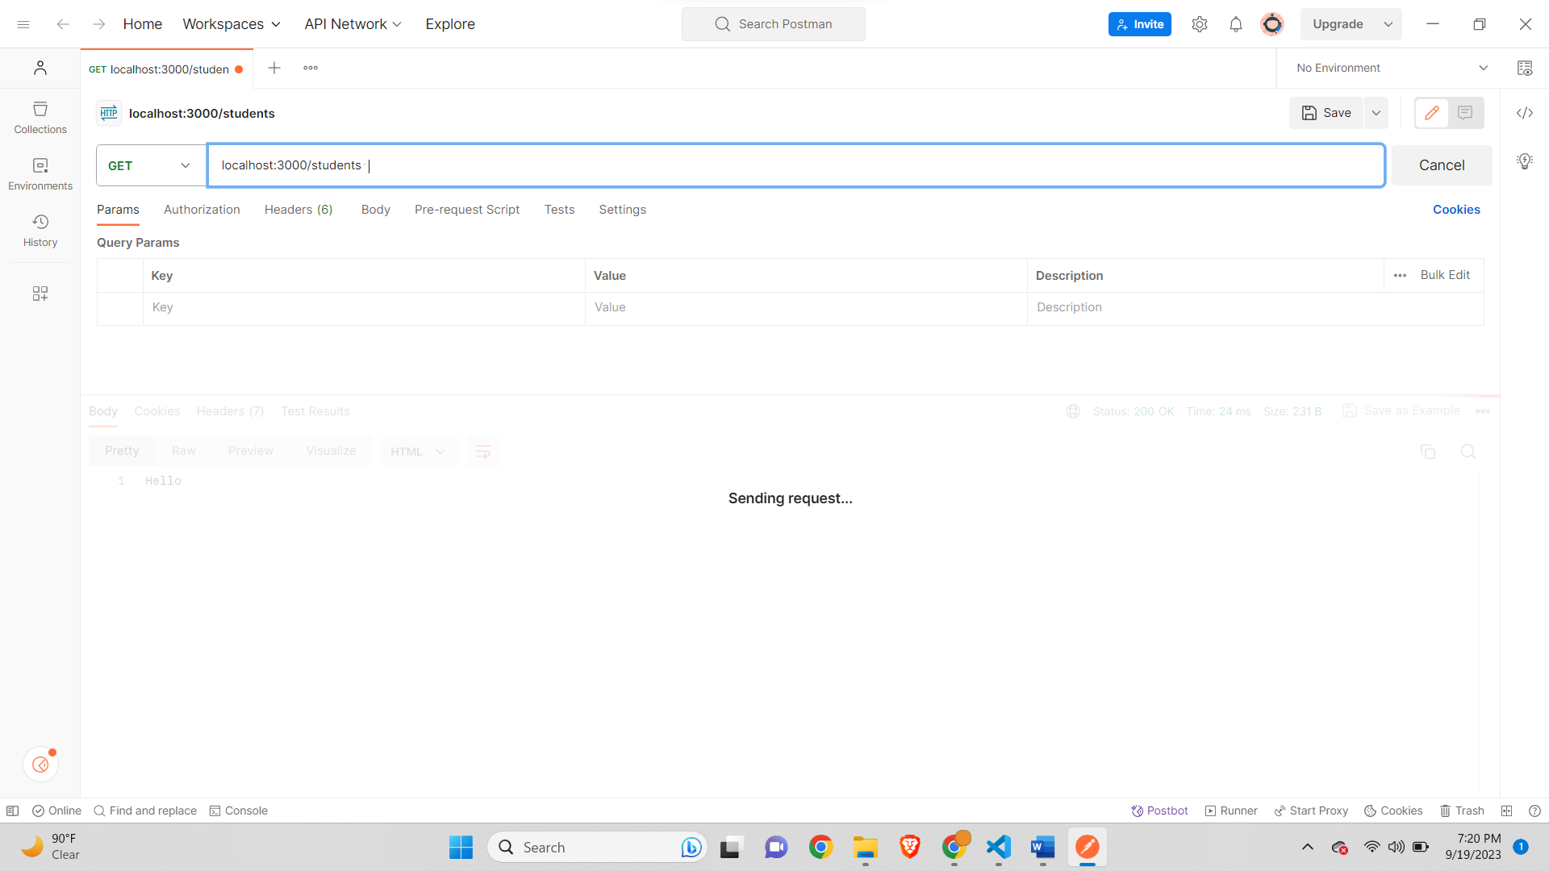

**After leaving Debugger-**

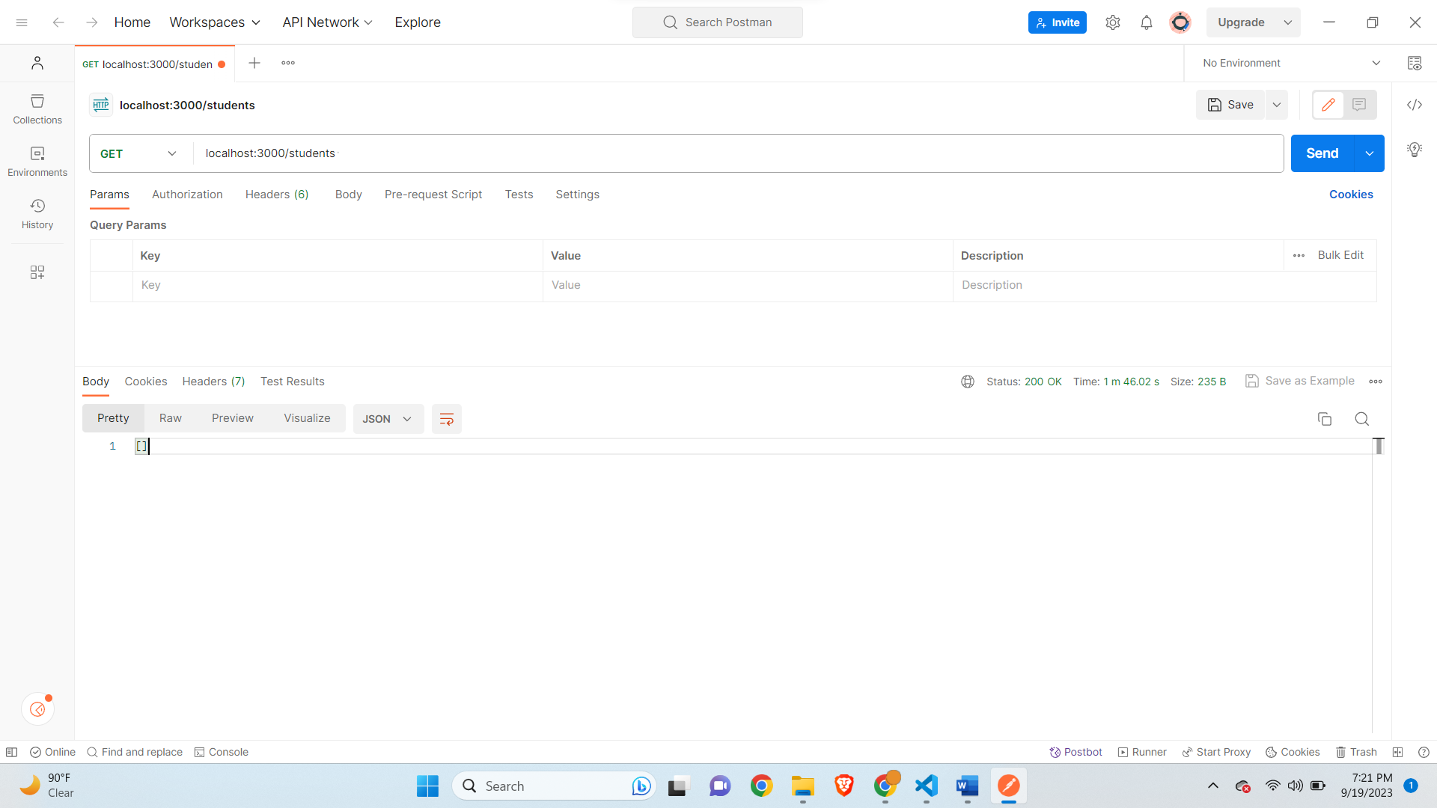

**POST Student-**

**Object in body in Postman-**

{

    "fname":"jake",

    "mname":"m",

    "lname":"moore",

    "age": 8,

    "address": "302 Main Street",

    "cell":"480-890-8811"

}

**Debugger stuck-**

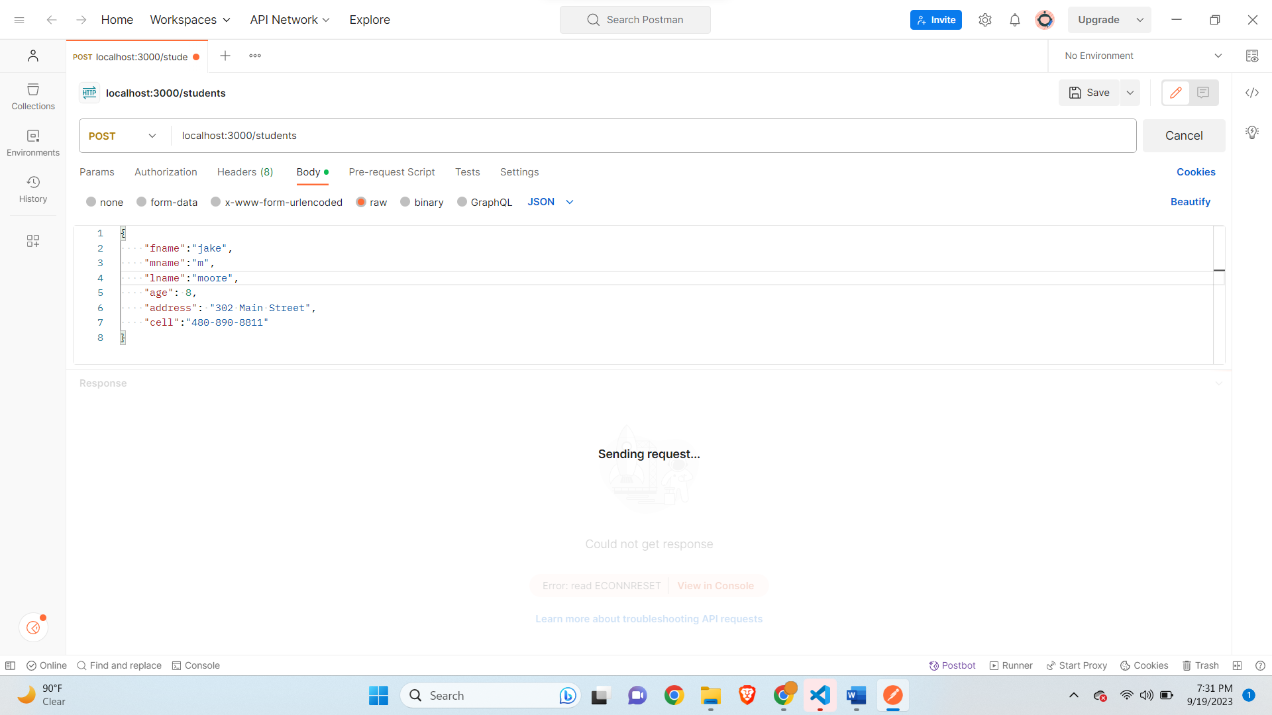

**Code Debugger-**

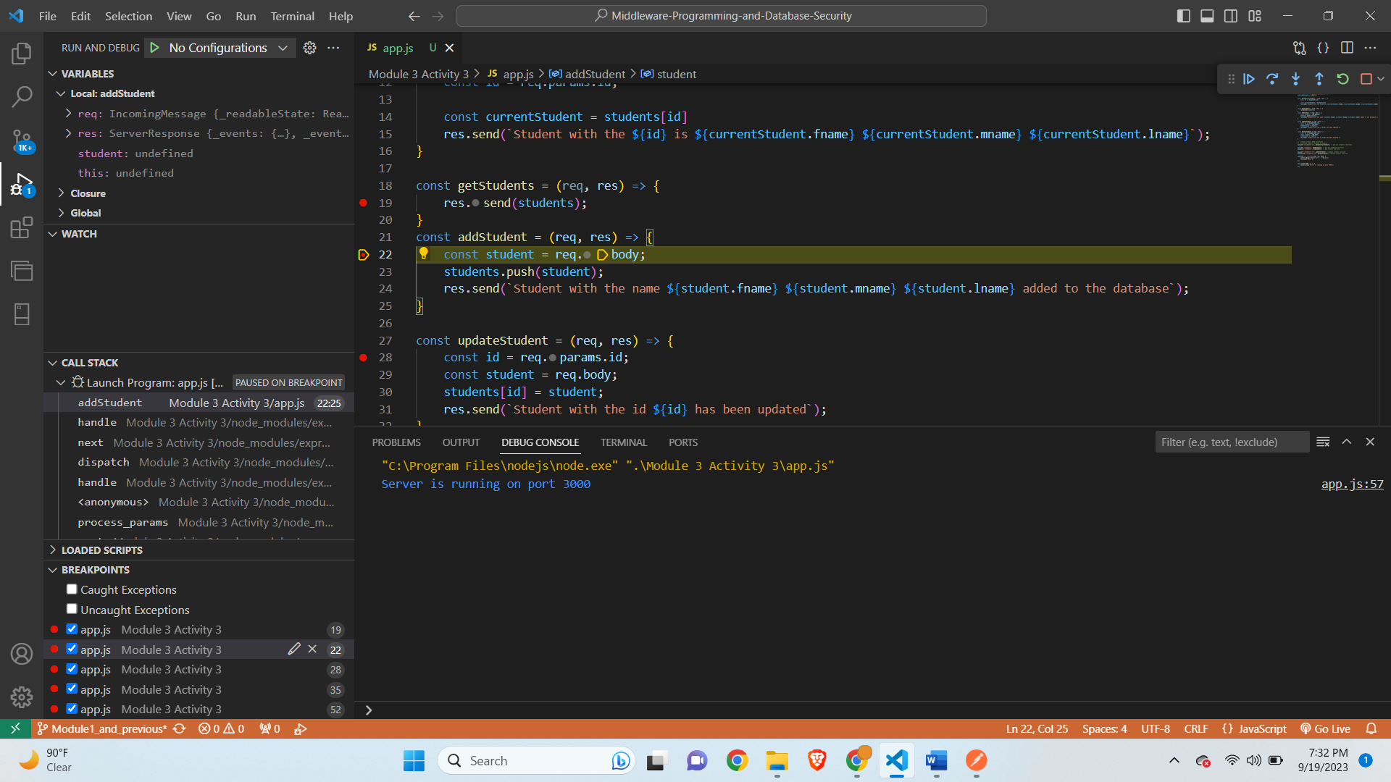

**After Leaving Debugger-**

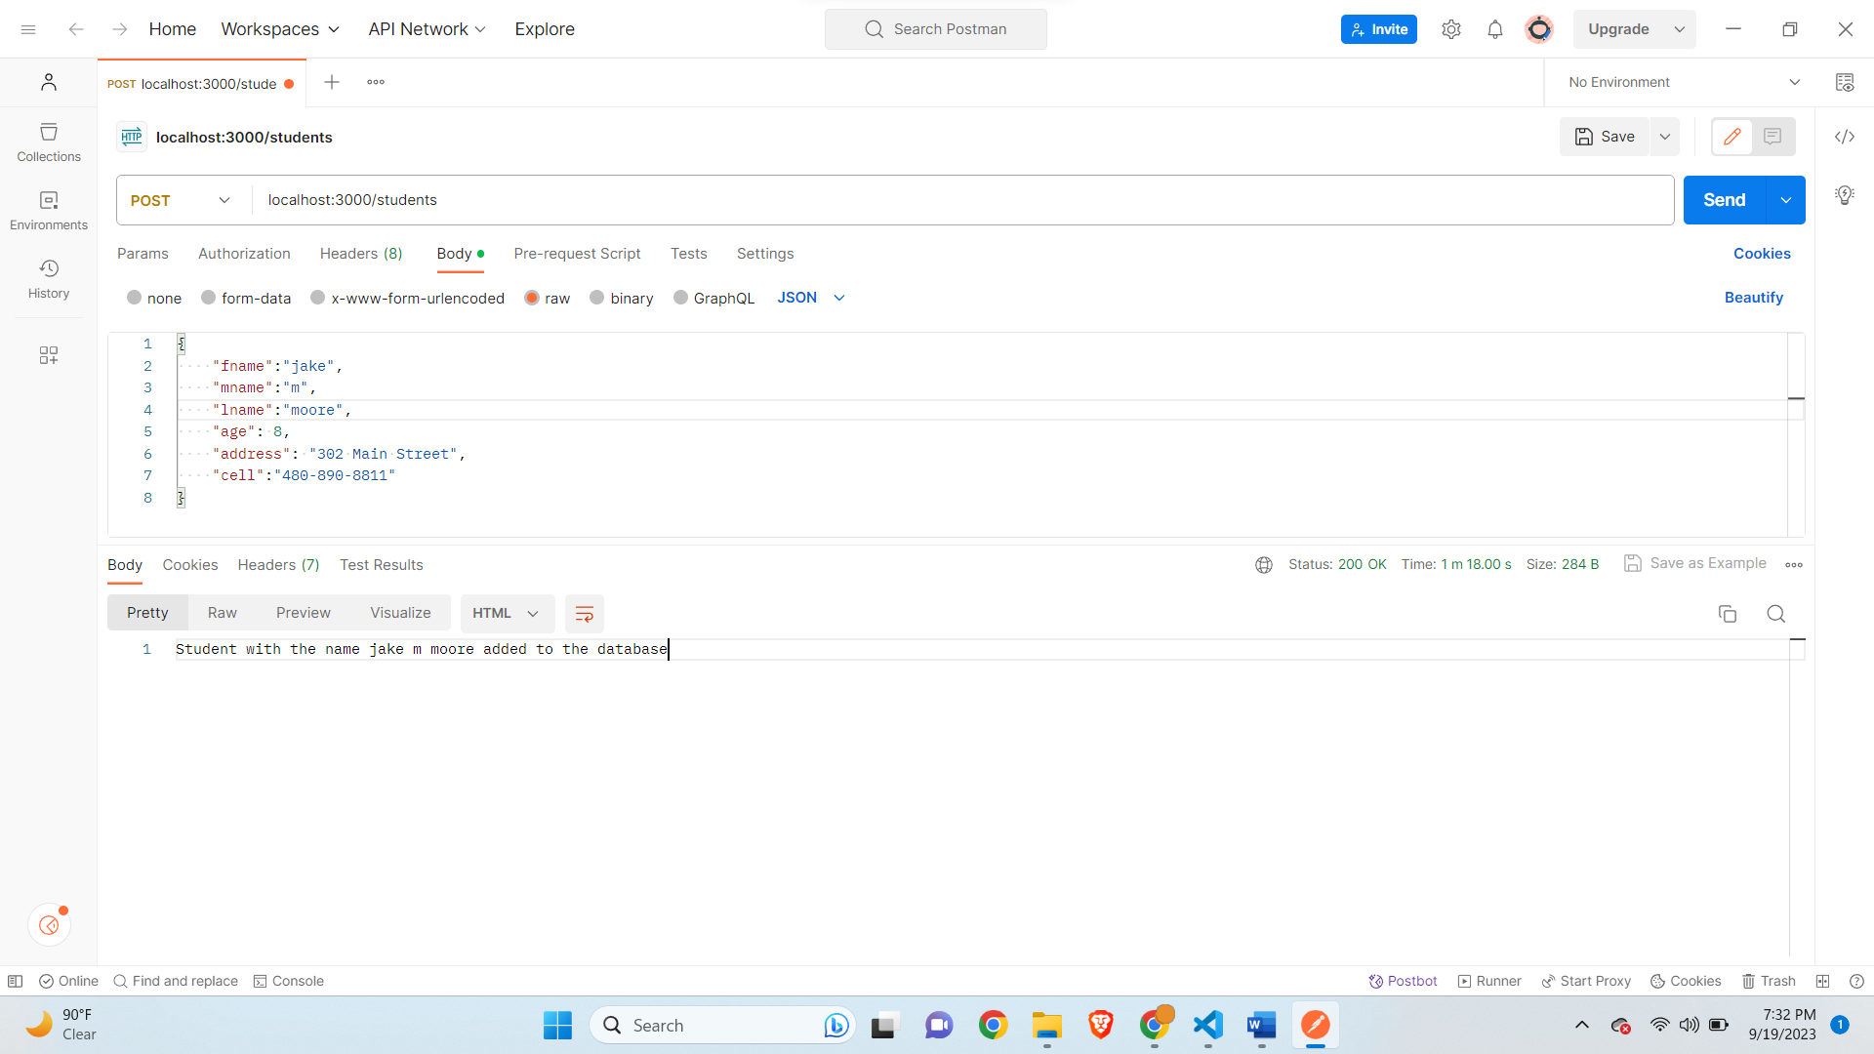

**Get students after adding student-**

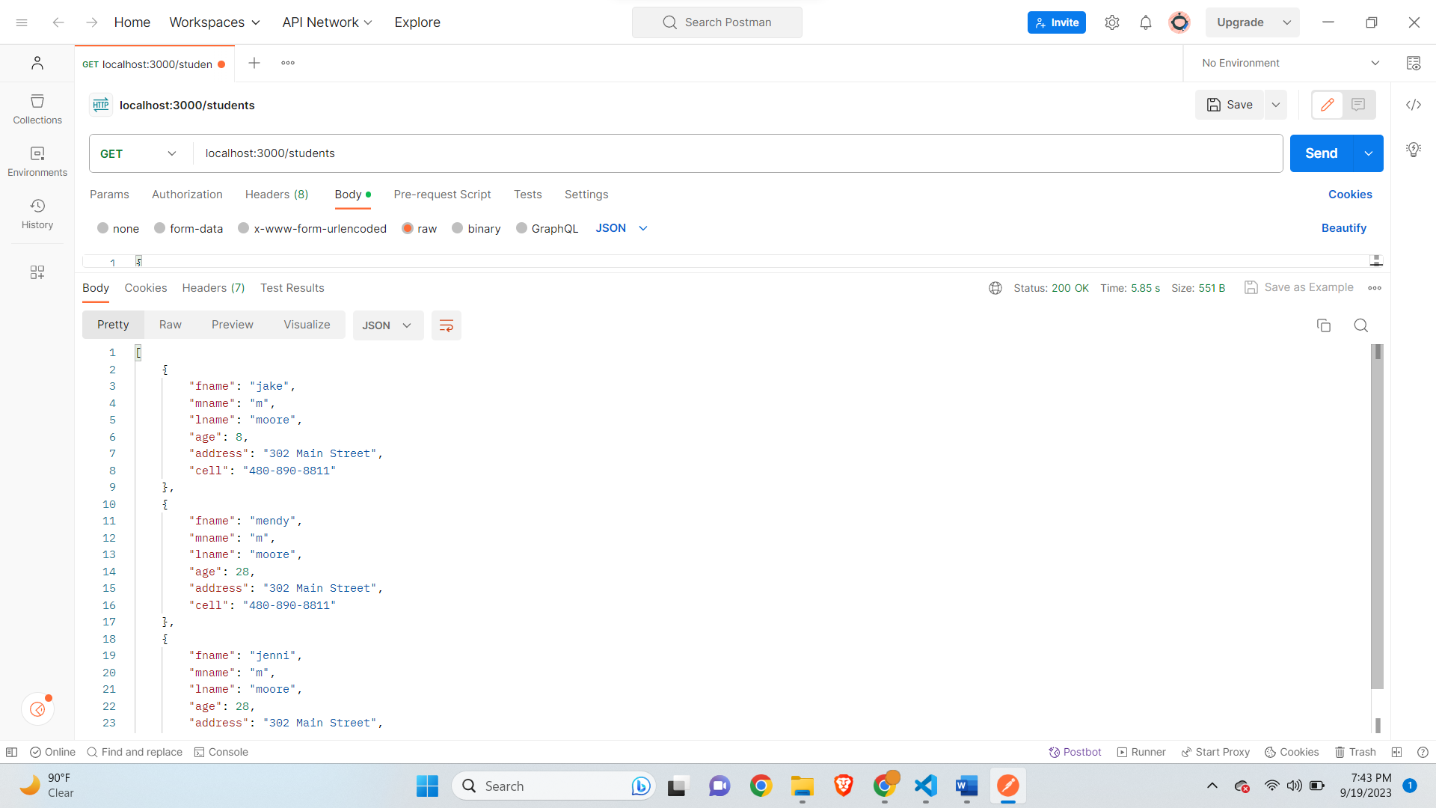

**PUT for student stuck in debugger-**

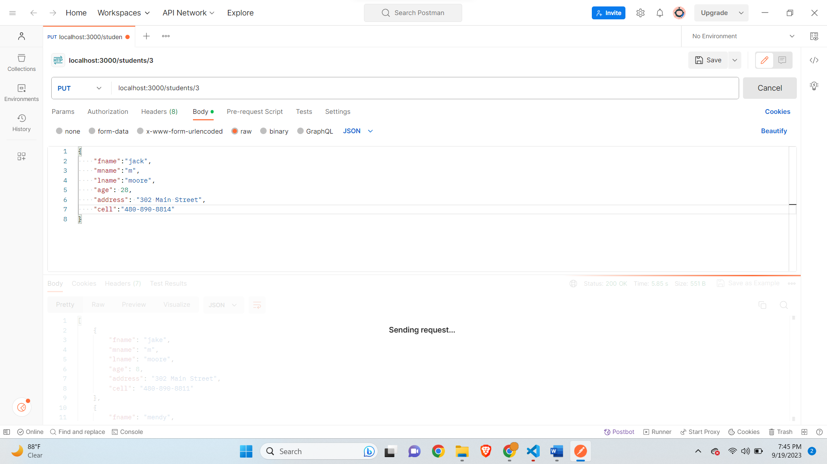

**Debugger stuck in code-**

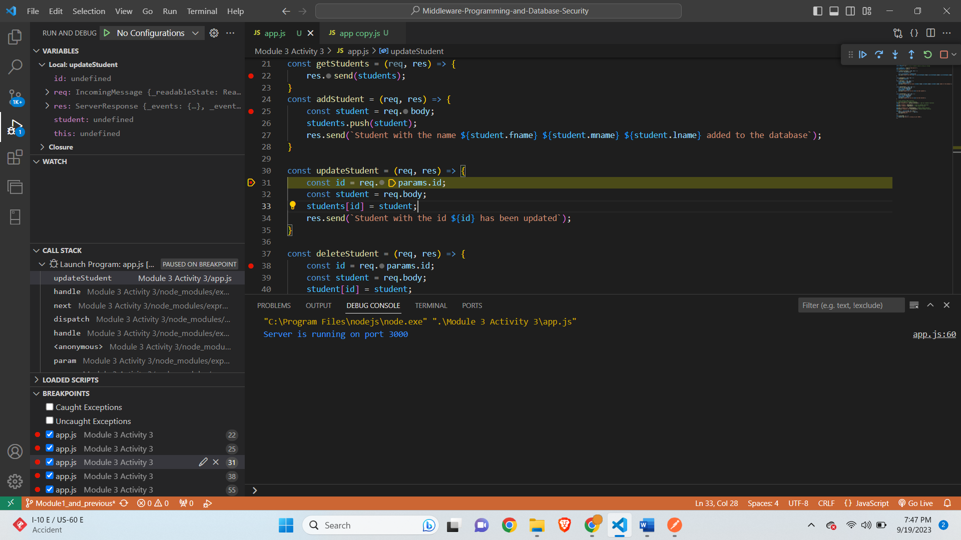

**After Leaving Debugger-**

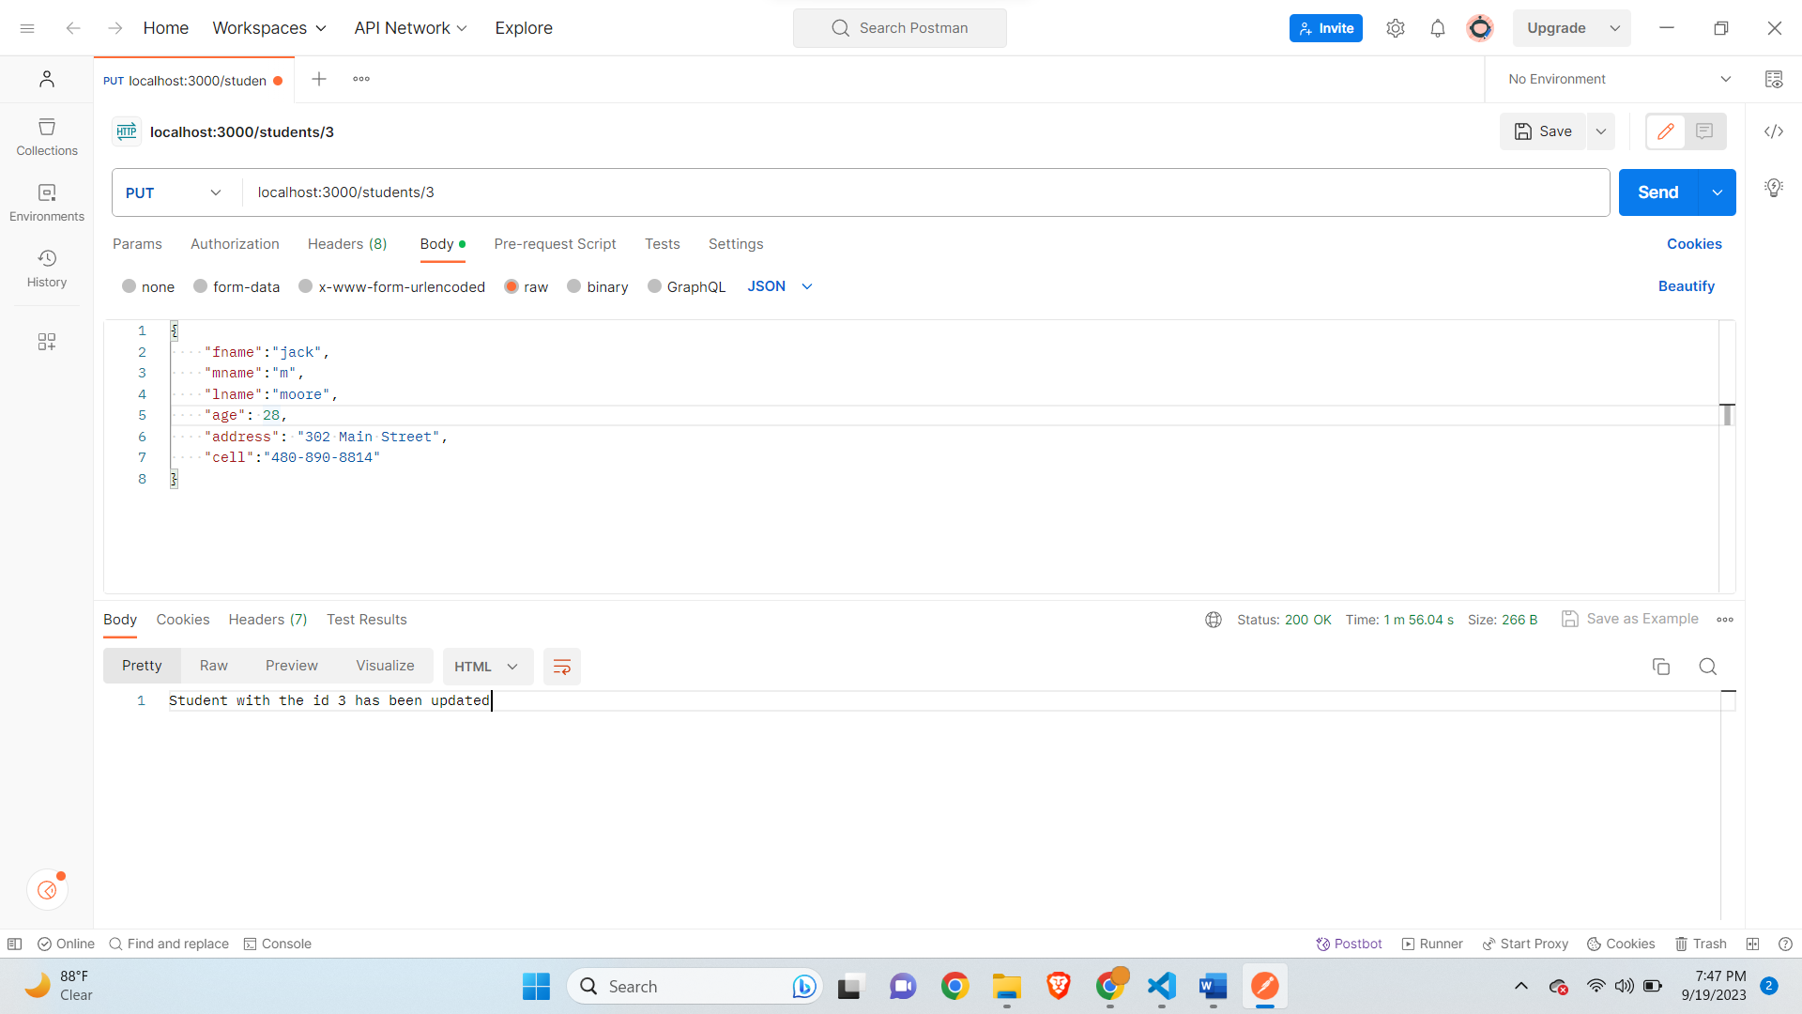

**Get Specific Student with Id stuck in debugger-**

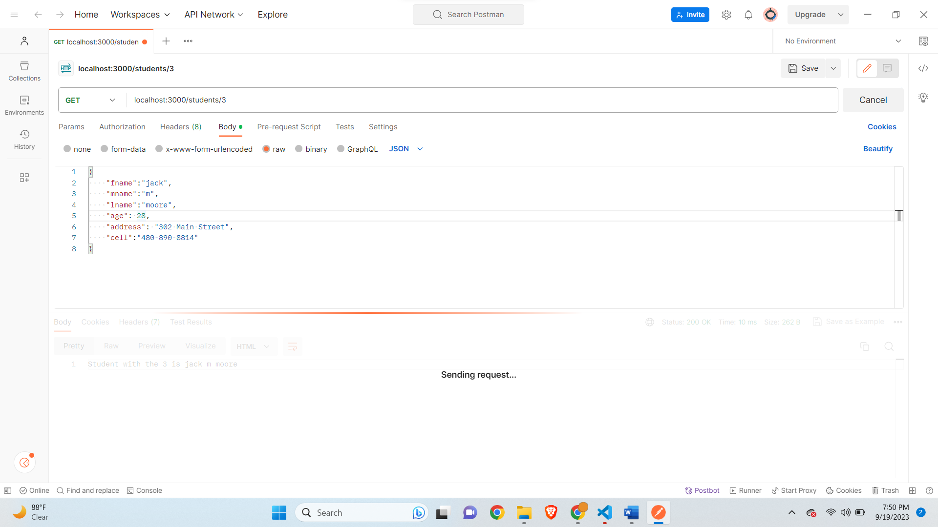

**Stuck in debugger for specific Id-**

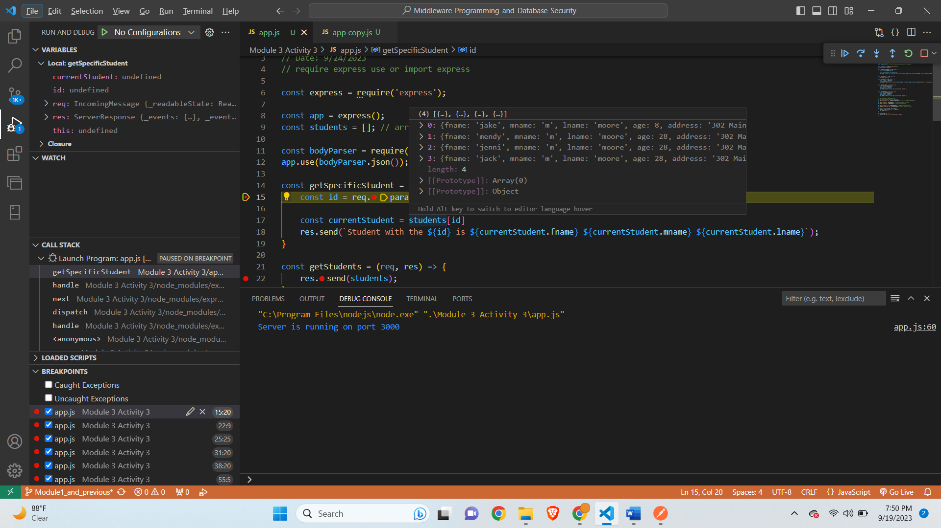

**After leaving debugger-**

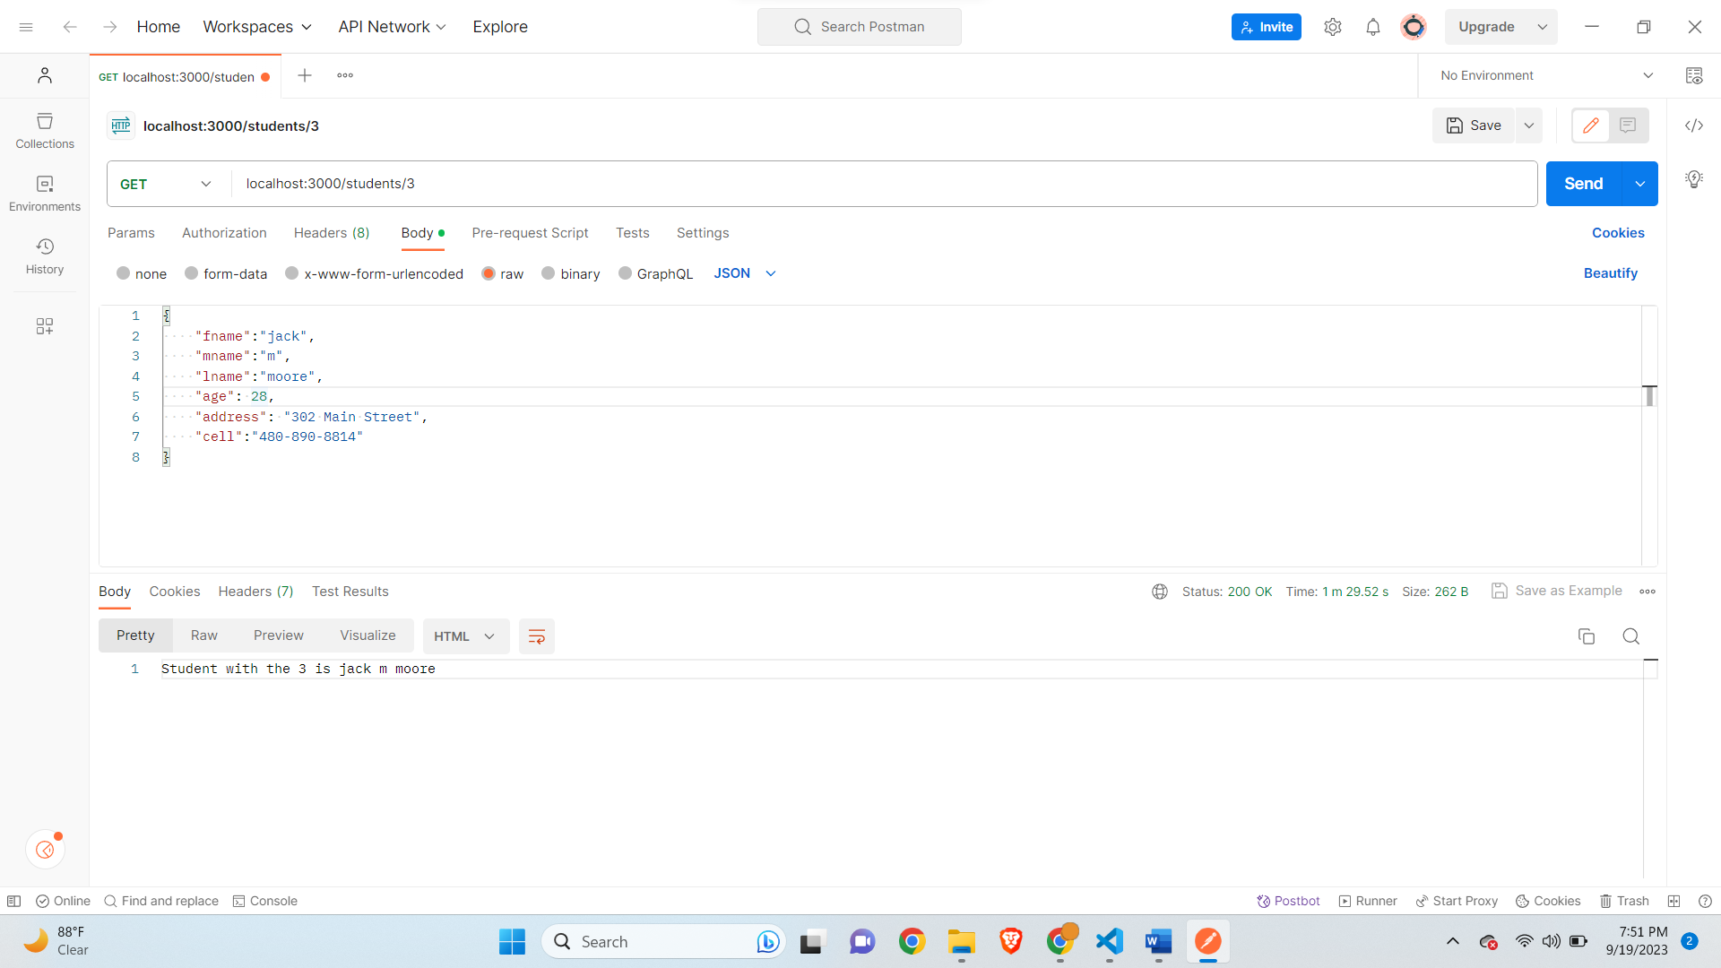

**Debugger Stuck for students get-**

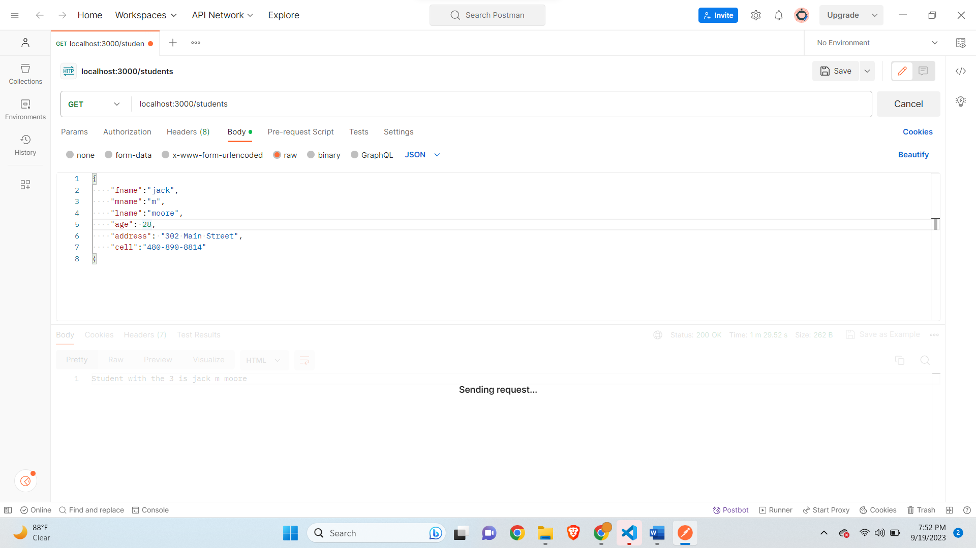

**Debugger in code-**

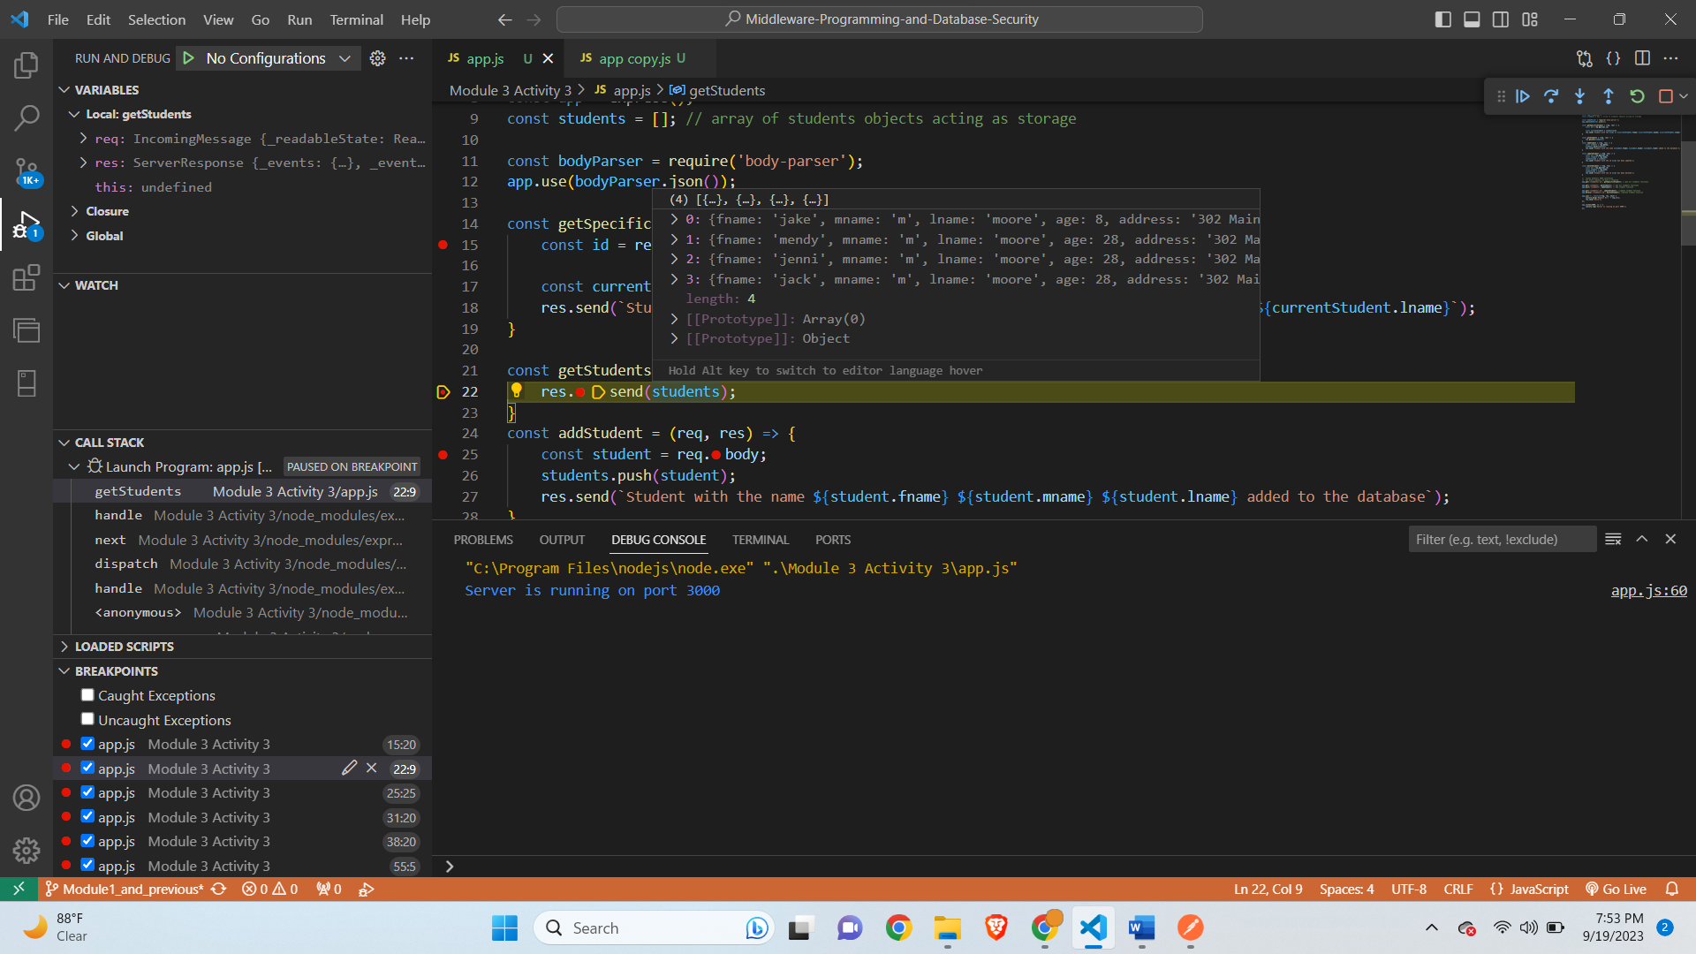

**After leaving Debugger-**

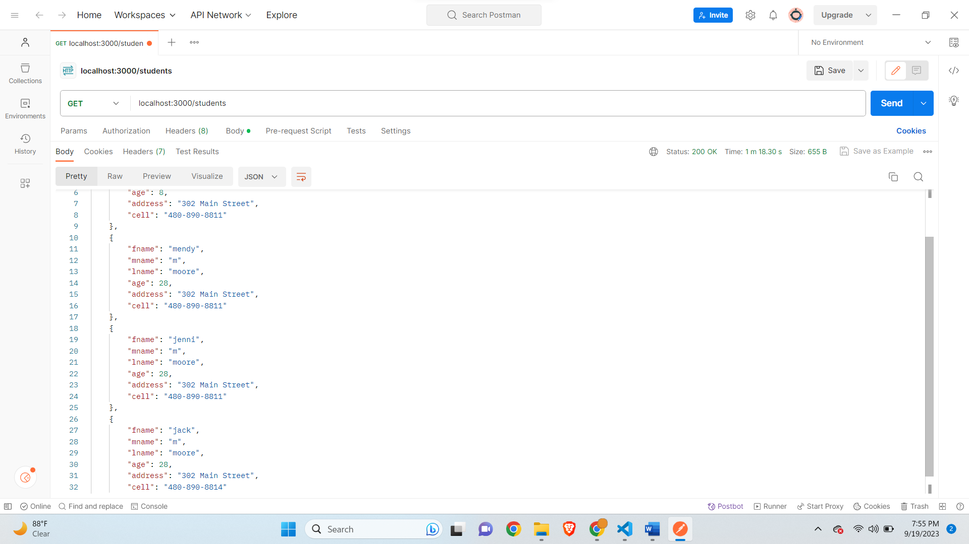

**Delete for Specific Student Debugger stuck-**

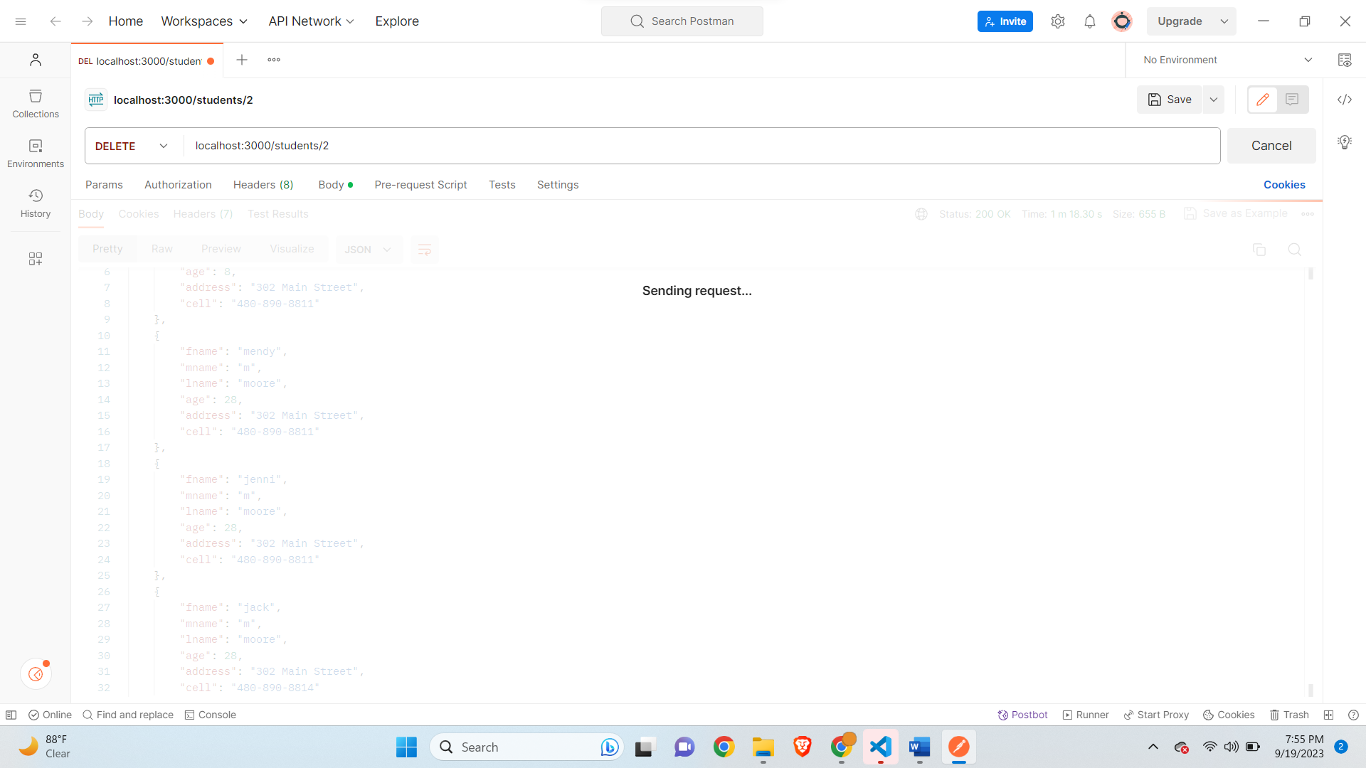

**Delete for specific student code debugger stuck-**

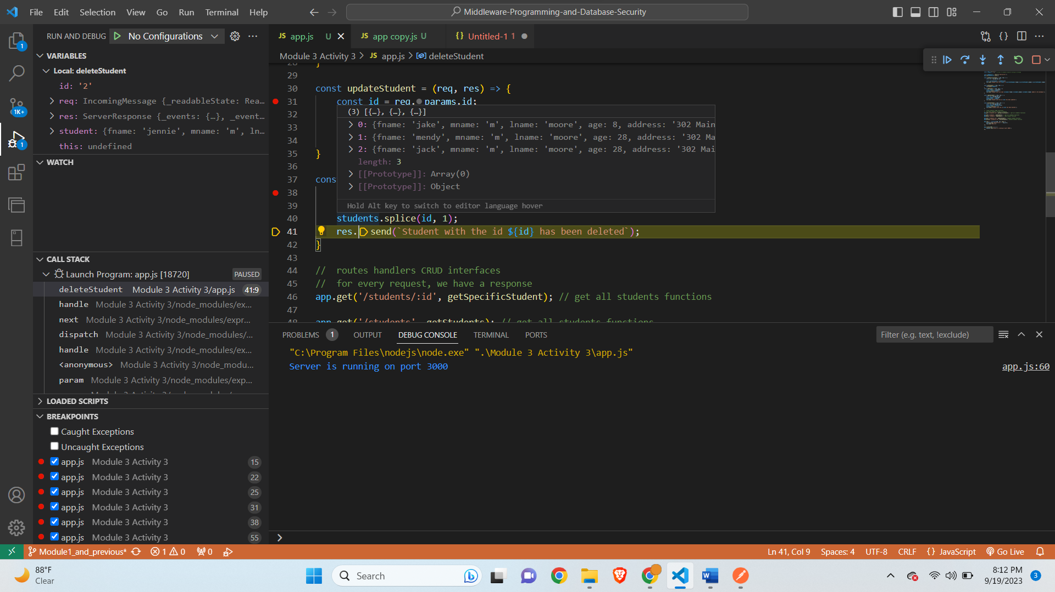

**After leaving debugger-**

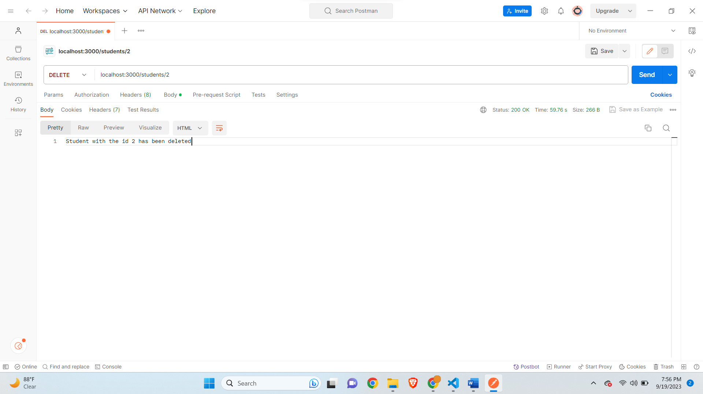

**Get All students-**

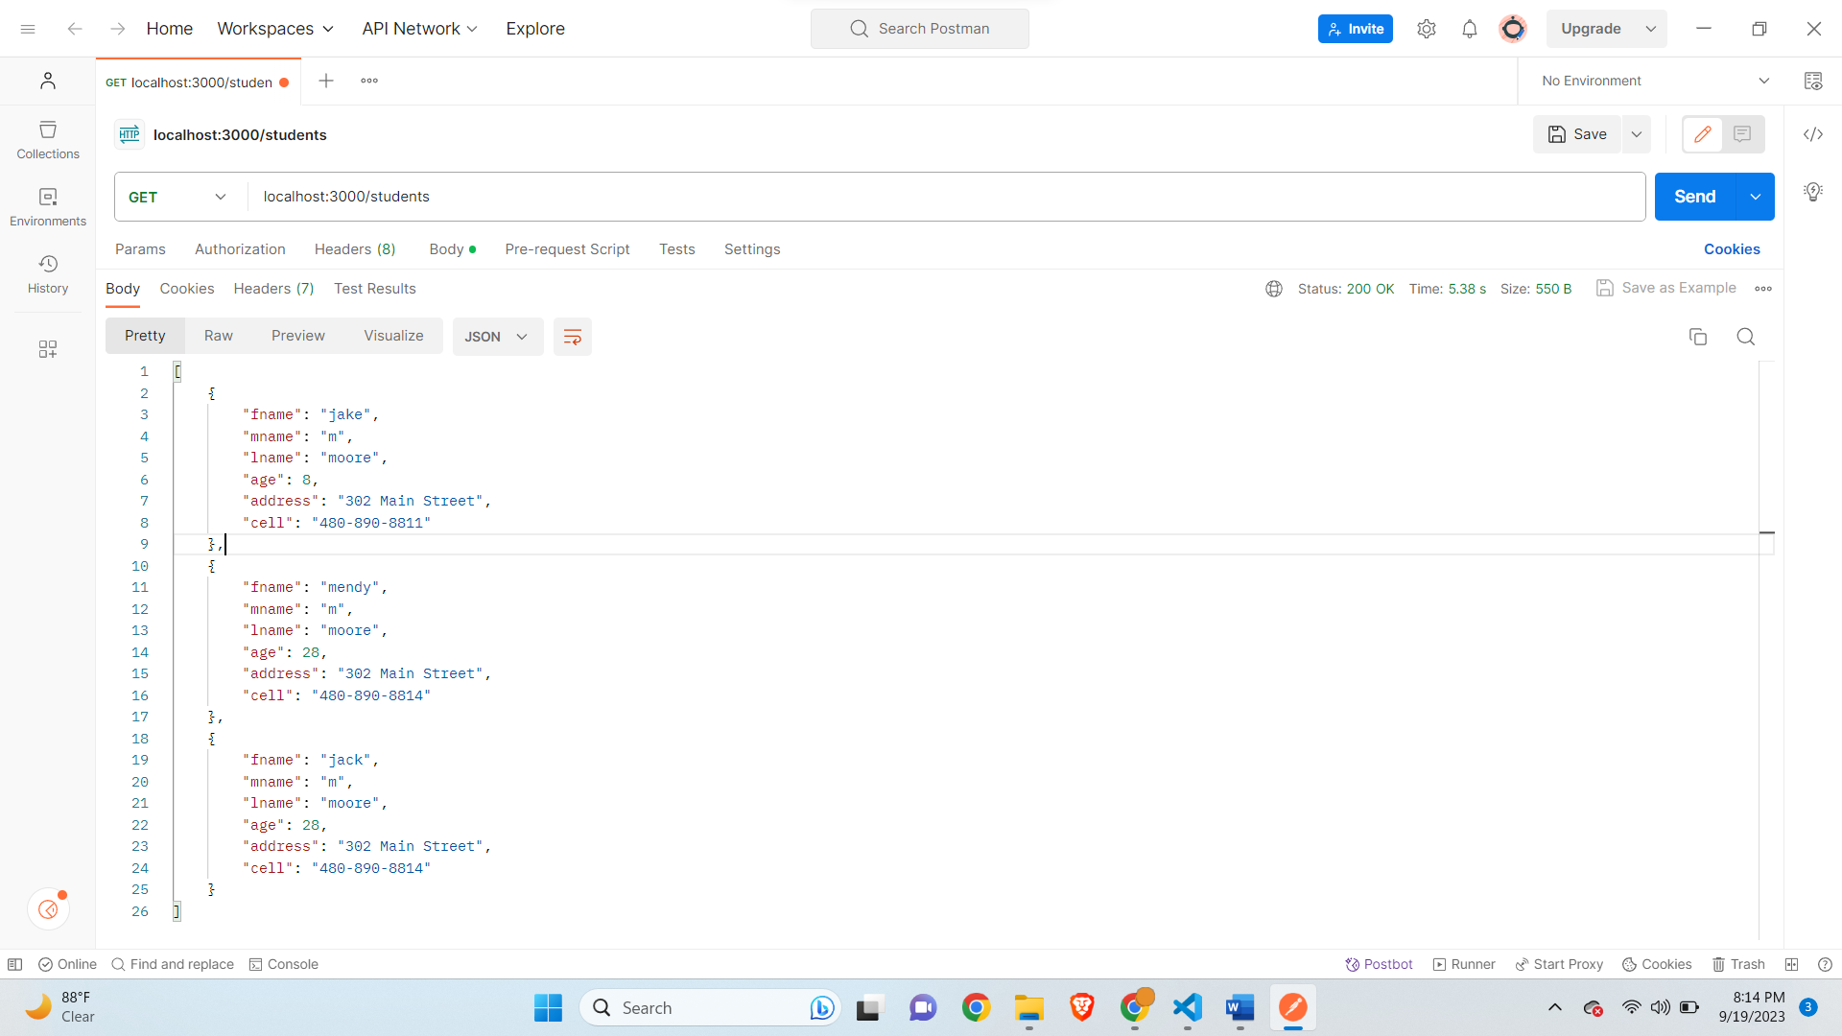

**Delete student with id 0-**

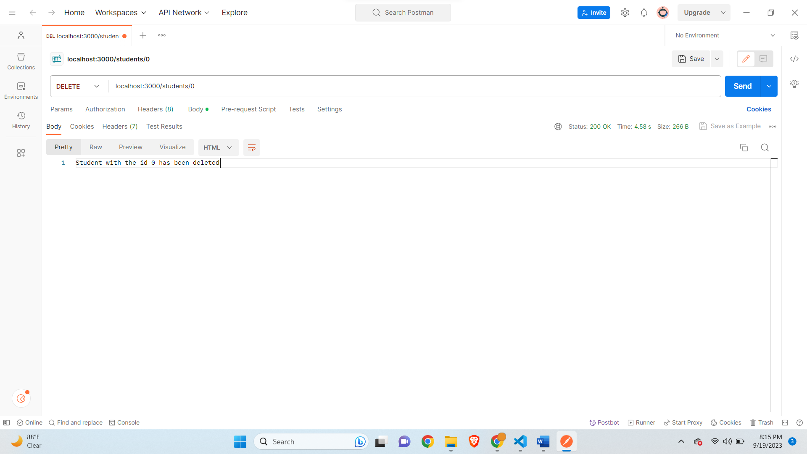

**Get all Students-**

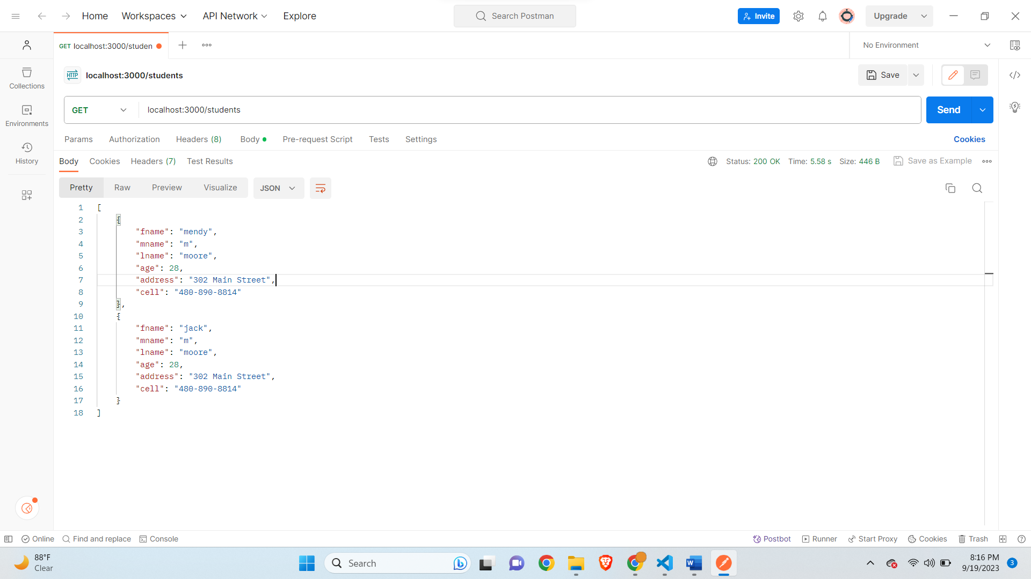

**Getting error for id which is not present-**

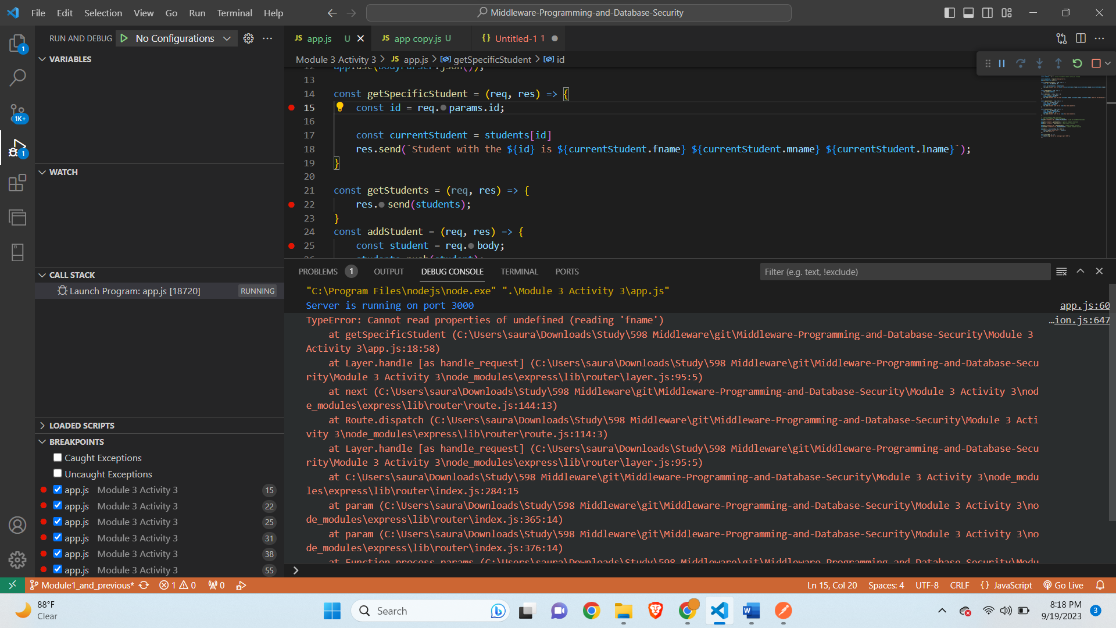

**Handling the error condition-**

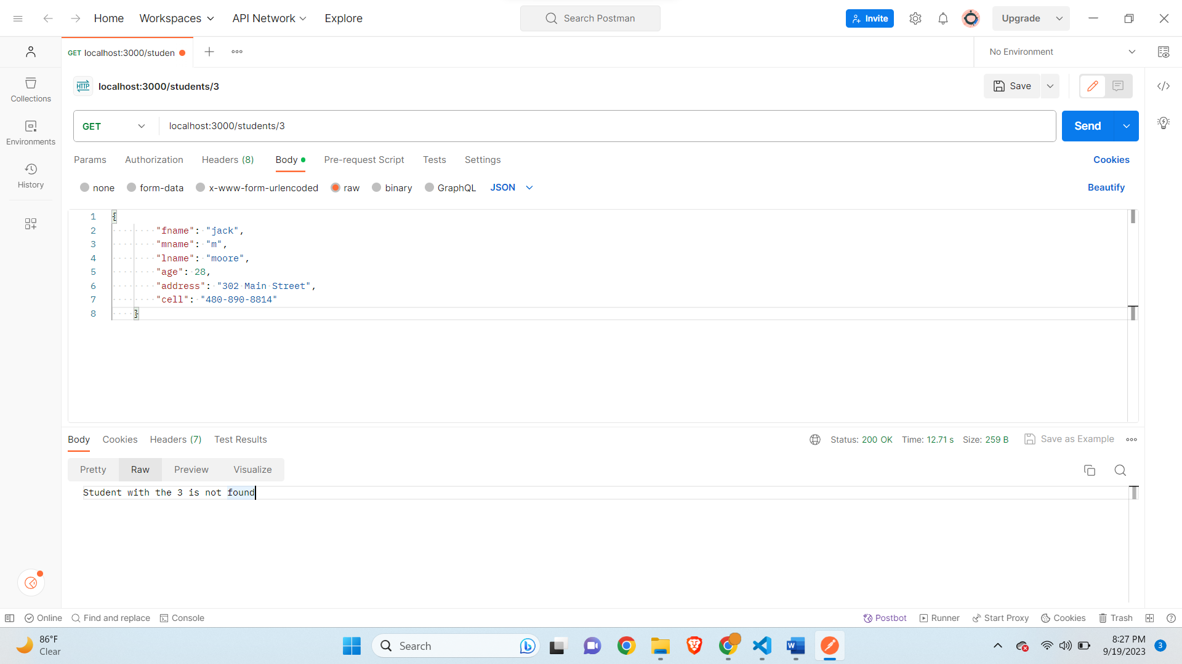

**Designing a Middleware for End-User Information Processing**

Authentication Middleware serves as a crucial middleware component, optimizing user authentication within web applications. Its primary objective lies in the validation of user credentials, effective management of user sessions, and meticulous tracking of authentication-related events. By undertaking these pivotal tasks, it streamlines development efforts and bolsters security protocols.

Key Functions:

1. **User Verification:** At its core, Authentication Middleware authenticates users by cross-referencing the credentials they provide (typically a username and password) with the stored user data contained within the middleware.
2. **Comprehensive Logging:** This middleware meticulously logs essential authentication events, encompassing both successful and unsuccessful login attempts. This logging is indispensable for comprehensive security auditing and vigilant monitoring.
3. **Session Mastery:** Authentication Middleware assumes responsibility for the creation and upkeep of user sessions, ensuring that authorized users remain securely logged in.
4. **Error Handling:** In the face of authentication issues, the middleware adeptly manages them, delivering informative error messages to users and developers when problems surface.

Processed Data Types: Authentication Middleware chiefly deals with user credentials throughout the authentication process. It scrutinizes the credentials provided by users to establish their access rights.

Middleware Operations:

1. **Authentication:** Throughout the login process, Authentication Middleware cross-references user-supplied credentials (username and password) with the stored user database to validate authenticity.
2. **Logging:** It diligently tracks authentication events, including successful logins and unsuccessful attempts, reinforcing security measures.
3. **Session Management:** The middleware generates and maintains user sessions, ensuring users remain logged in as required. Additionally, it adeptly addresses authentication-related issues such as invalid credentials, session expirations, and account lockouts.

Interactions with Other Systems/Applications: • **Data Retrieval:** Authentication Middleware retrieves user account information from the user database. • **Request Handling:** It intercepts login requests from the web application's front end, verifying user credentials before granting access. • **Response Handling:** Following successful authentication, it furnishes user data to the web application for authorization and customization.

Developer Advantages: • **Streamlined Development:** Web application developers can concentrate on core business logic and user interfaces without the need to construct intricate authentication logic from scratch. • **Elevated Security:** By enforcing secure and consistent authentication methods, the middleware mitigates the risk of security vulnerabilities. • **Scalability:** As the web application expands, the middleware seamlessly manages user authentication with minimal code adjustments. • **Modularity:** Isolating authentication logic from the primary application promotes a modular and maintainable codebase.

Through the incorporation of Authentication Middleware, developers can elevate both the security and user-friendliness of their web applications. This middleware facilitates the adoption of standardized authentication components, reducing development time and effort. With this middleware integrated into their systems, developers can channel their efforts into crafting the core functionality of the application, culminating in a more efficient and secure development process.

**Interaction Diagram-**

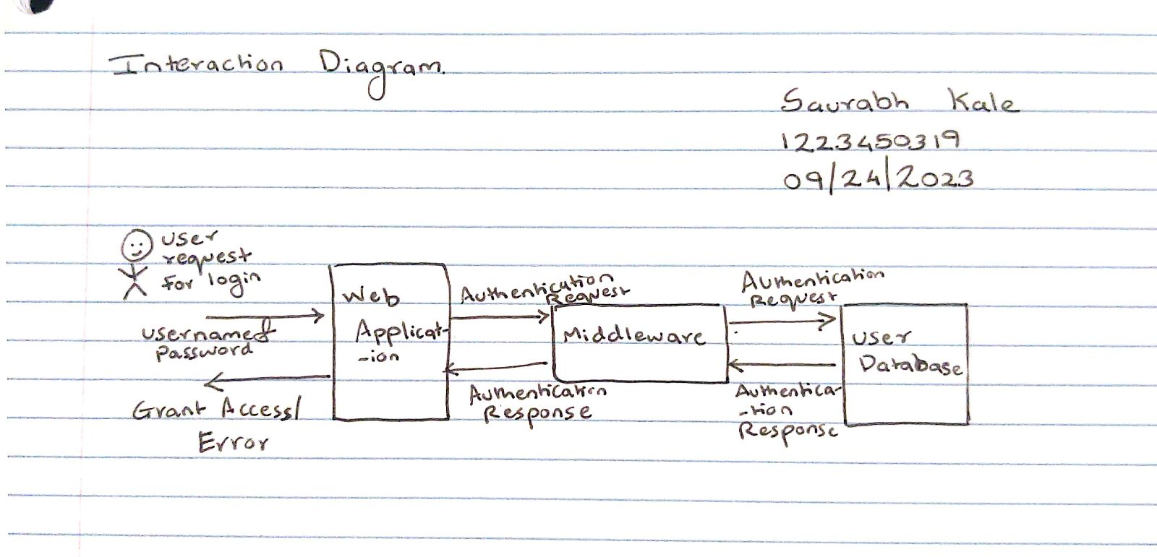

This project has proven to be an invaluable learning journey, offering a plethora of significant insights and key takeaways. Most notably, it has underscored the critical importance of problem-solving within the realm of software development. From addressing seemingly minor issues like missing essential modules such as express and body-parser to tackling more intricate challenges like debugging server responses, this experience has reinforced the notion that as developers, we must always be equipped to troubleshoot and surmount obstacles that may emerge during the development process.

One of the highlights of the coding process is undoubtedly the debugging phase. It is imperative to identify the root cause of any error before embarking on the implementation of a solution. Such an approach not only aids in resolving the immediate issue but also enriches one's comprehension of the codebase. Moreover, the experience of utilizing Postman to test a variety of HTTP methods, including GET, PUT, POST, and DELETE, has been enlightening. It has functioned as an invaluable learning platform, particularly beneficial for individuals aspiring to enter the IT industry, providing a hands-on opportunity to engage with and comprehend API endpoints.

Additionally, this project has imparted a profound appreciation for the pivotal role played by middleware in the realm of software development. Middleware serves as a potent instrument in simplifying the development process by abstracting intricate operations like authentication. This abstraction enables developers to channel their efforts towards crafting innovative and feature-rich applications, all while ensuring standardized and secure data processing. Middleware acts as an intermediary, smoothing the flow of information and elevating the overall efficiency of software ecosystems.

In summation, this assignment has deepened my comprehension of middleware's pivotal role in facilitating the efficient flow and processing of data within complex software environments. It has emphasized the significance of meticulous design, robust security measures, and scalability considerations when crafting middleware solutions. As I continue to progress in my journey as a developer, these insights are poised to significantly enhance my capacity to construct resilient and user-friendly software systems.

**Part B-**

**App.js Updated Code-**

// Name: Saurabh Kale

// ASUID: 1223450319

// Date: 9/24/2023

// require express use or import express

const express = require('express');

const app = express();

const students = []; // array of students objects acting as storage

const bodyParser = require('body-parser');

app.use(bodyParser.json());

//change the name to uppercase

const makeUpperCase = (req, res, next) => {

    const student = req.body;

    if(req.body.fname == undefined || req.body.mname == undefined || req.body.lname == undefined){

        return res.send('Please enter a valid name');

    }

    req.body.fname = student.fname.toUpperCase();

    req.body.mname = student.mname.toUpperCase();

    req.body.lname = student.lname.toUpperCase();

    next();

}

app.use(makeUpperCase);

const getSpecificStudent = (req, res) => {

    const id = req.params.id;

    const currentStudent = students[id]

    if(currentStudent === undefined){

        res.send(`Student with the ${id} is not found`)

    }

    res.send(`Student with the ${id} is ${currentStudent.fname} ${currentStudent.mname} ${currentStudent.lname}`);

}

const getStudents = (req, res) => {

    res.send(students);

}

const addStudent = (req, res) => {

    const student = req.body;

    students.push(student);

    res.send(`Student with the name ${student.fname} ${student.mname} ${student.lname} added to the database`);

}

const updateStudent = (req, res) => {

    const id = req.params.id;

    const student = req.body;

    students[id] = student;

    res.send(`Student with the id ${id} has been updated`);

}

const deleteStudent = (req, res) => {

    const id = req.params.id;

    const student = students[id];

    students.splice(id, 1);

    res.send(`Student with the id ${id} has been deleted`);

}

//  routes handlers CRUD interfaces

//  for every request, we have a response

app.get('/students/:id', getSpecificStudent); // get all students functions

app.get('/students', getStudents); // get all students functions

app.post('/students', addStudent); // add student function

app.put('/students/:id', updateStudent); //update student function

app.delete('/students/:id', deleteStudent); //delete student function

app.use('/', function(req, res, next) {

    console.log('Request Url:' + req.url);

    res.send('Hello');

});

app.listen(3000, () => {

    console.log('Server is running on port 3000');

});

**Debugger in upper case-**

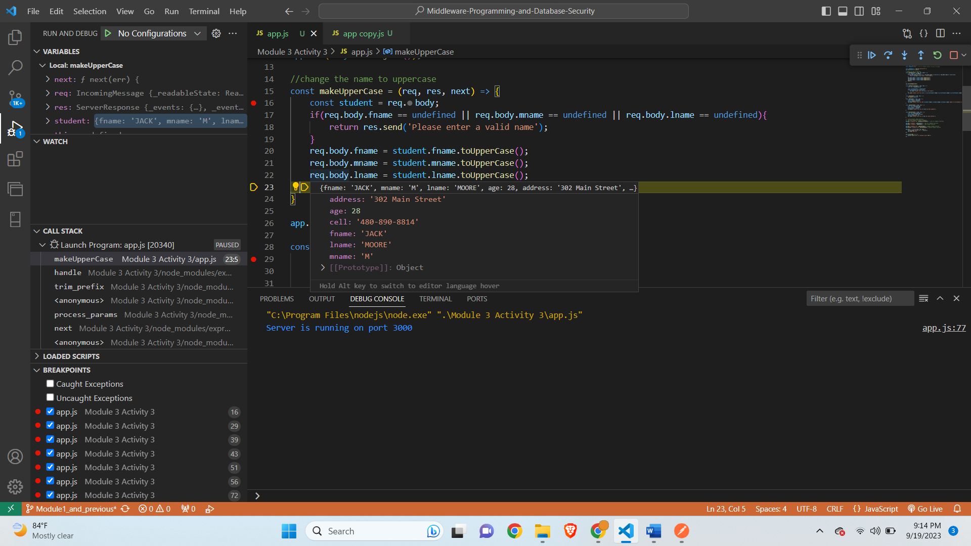

**After continuing debugger-**

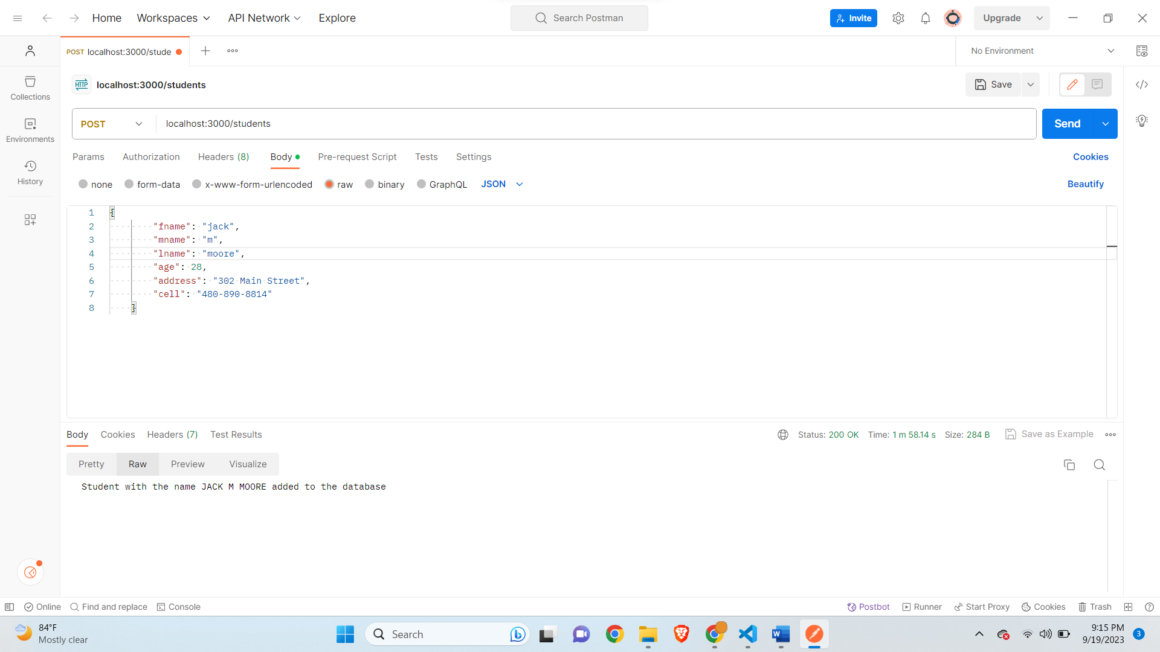

**Get all Students for upperCase-**

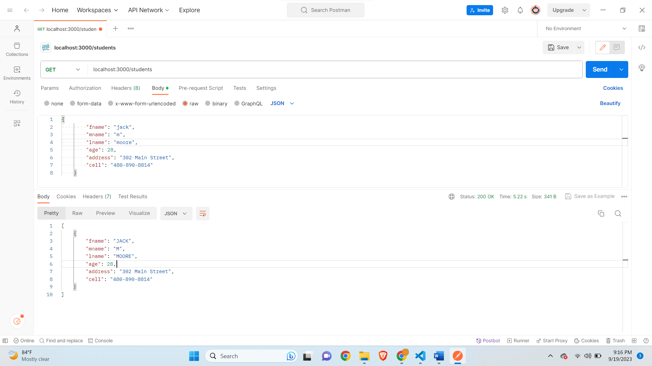

**Admin Check Added-**

**app.js-**

// Name: Saurabh Kale

// ASUID: 1223450319

// Date: 9/24/2023

// require express use or import express

const express = require('express');

const app = express();

const students = []; // array of students objects acting as storage

const bodyParser = require('body-parser');

app.use(bodyParser.json());

//change the name to uppercase

const makeUpperCase = (req, res, next) => {

    const student = req.body;

    if(req.body.fname == undefined || req.body.mname == undefined || req.body.lname == undefined){

        return res.send('Please enter a valid name');

    }

    req.body.fname = student.fname.toUpperCase();

    req.body.mname = student.mname.toUpperCase();

    req.body.lname = student.lname.toUpperCase();

    next();

}

const checkAdmin = (req, res, next) => {

    if(req.query.admin === 'true'){

        next();

    } else{

        res.status(400).send('Should be admin');

    }

}

app.use(makeUpperCase);

const getSpecificStudent = (req, res) => {

    const id = req.params.id;

    const currentStudent = students[id]

    if(currentStudent === undefined){

        res.send(`Student with the ${id} is not found`)

    }

    res.send(`Student with the ${id} is ${currentStudent.fname} ${currentStudent.mname} ${currentStudent.lname}`);

}

const getStudents = (req, res) => {

    res.send(students);

}

const addStudent = (req, res) => {

    const student = req.body;

    students.push(student);

    res.send(`Student with the name ${student.fname} ${student.mname} ${student.lname} added to the database`);

}

const updateStudent = (req, res) => {

    const id = req.params.id;

    const student = req.body;

    students[id] = student;

    res.send(`Student with the id ${id} has been updated`);

}

const deleteStudent = (req, res) => {

    const id = req.params.id;

    const student = students[id];

    students.splice(id, 1);

    res.send(`Student with the id ${id} has been deleted`);

}

//  routes handlers CRUD interfaces

//  for every request, we have a response

app.get('/students/:id',checkAdmin, getSpecificStudent); // get all students functions

app.get('/students', getStudents); // get all students functions

app.post('/students', addStudent); // add student function

app.put('/students/:id', updateStudent); //update student function

app.delete('/students/:id',checkAdmin, deleteStudent); //delete student function

app.use('/', function(req, res, next) {

    console.log('Request Url:' + req.url);

    res.send('Hello');

});

app.listen(3000, () => {

    console.log('Server is running on port 3000');

});

**Get Students-**

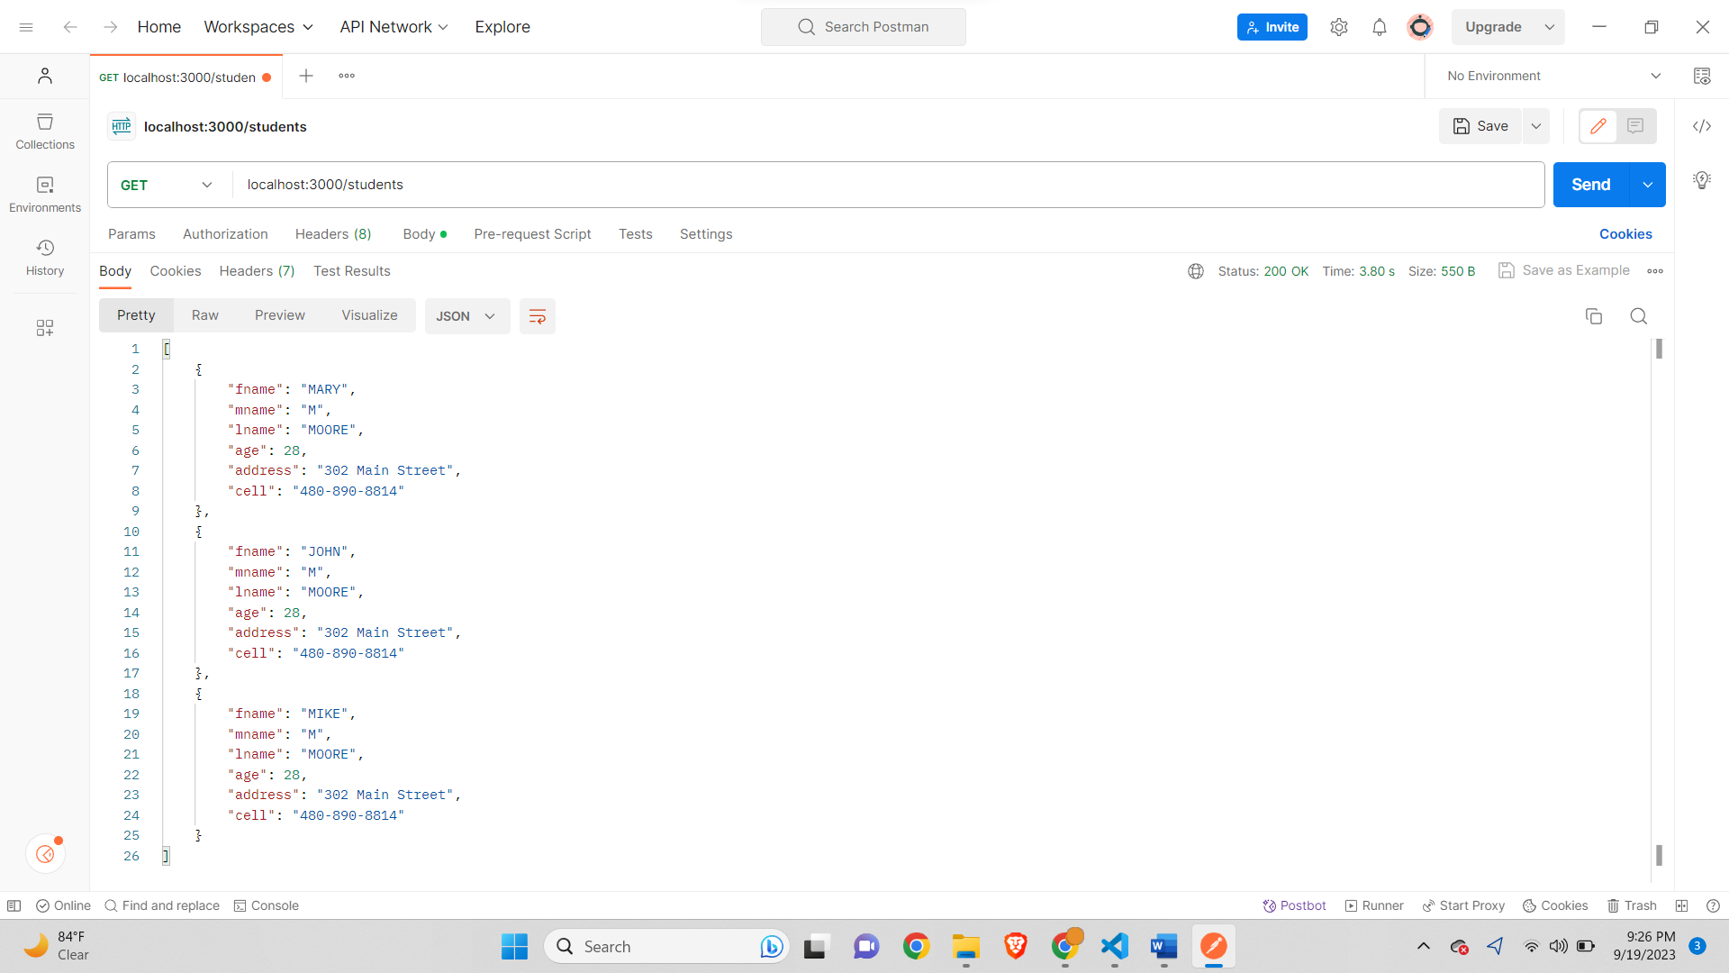

**Should be admin for GET-**

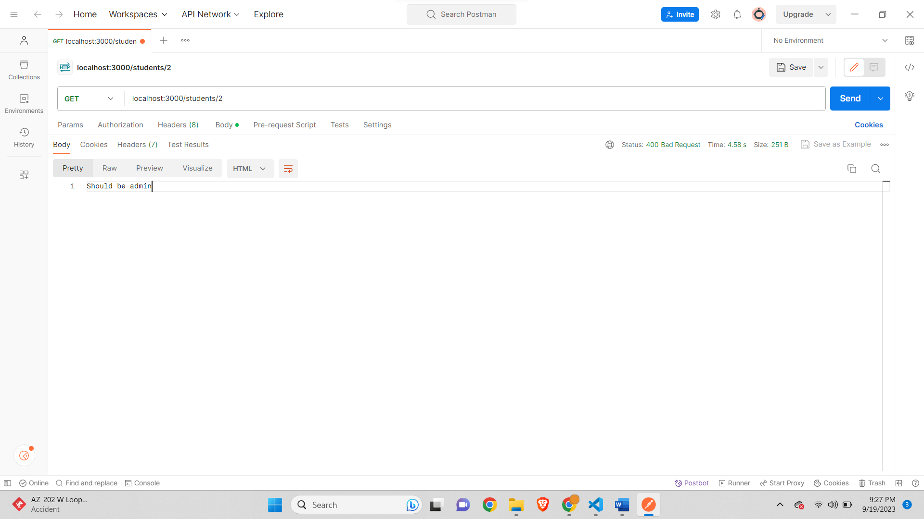

**Should be Admin for DELETE-**



**BookHub-**

**appBookHub.js-**

// Name: Saurabh Kale

// ASUID: 1223450319

// Date: 9/24/2023

// require express use or import express

const express = require('express');

const app = express();

const books = []; // array of book objects acting as storage

const bodyParser = require('body-parser');

app.use(bodyParser.json());

const checkAdmin = (req, res, next) => {

    console.log(req.query)

    if(req.query.admin === 'true'){

        next();

    } else{

        res.status(400).send('Should be admin');

    }

}

//Routes

app.get('/', (req,res) => {

    res.send(`Welcome to BookHub!`);

});

app.post('/cart/add', checkAdmin, (req,res) => {

    console.log(req.body)

    if(req.body.book!=undefined){

        books.push(req.body.book)

        res.send(`Book added New List- ${books}`);

    }

    else{

        res.send('Failed to add Book');

    }

});

app.delete('/cart/remove', checkAdmin, (req,res)=>{

    res.send(`All Book List removed Succesfully`)

})

app.delete('/cart/remove/:id', checkAdmin, (req,res)=>{

    const id = req.params.id;

    const currentBook = books[id]

    if(currentBook != undefined){

        books.splice(id, 1);

        res.send(`Book Removed New List- ${books}`);

    }

    else{

        res.send(`Book with the ${id} is not found`)

    }

})

app.listen(3000, () => {

    console.log('Server is running on port 3000');

});

**Default Route-**

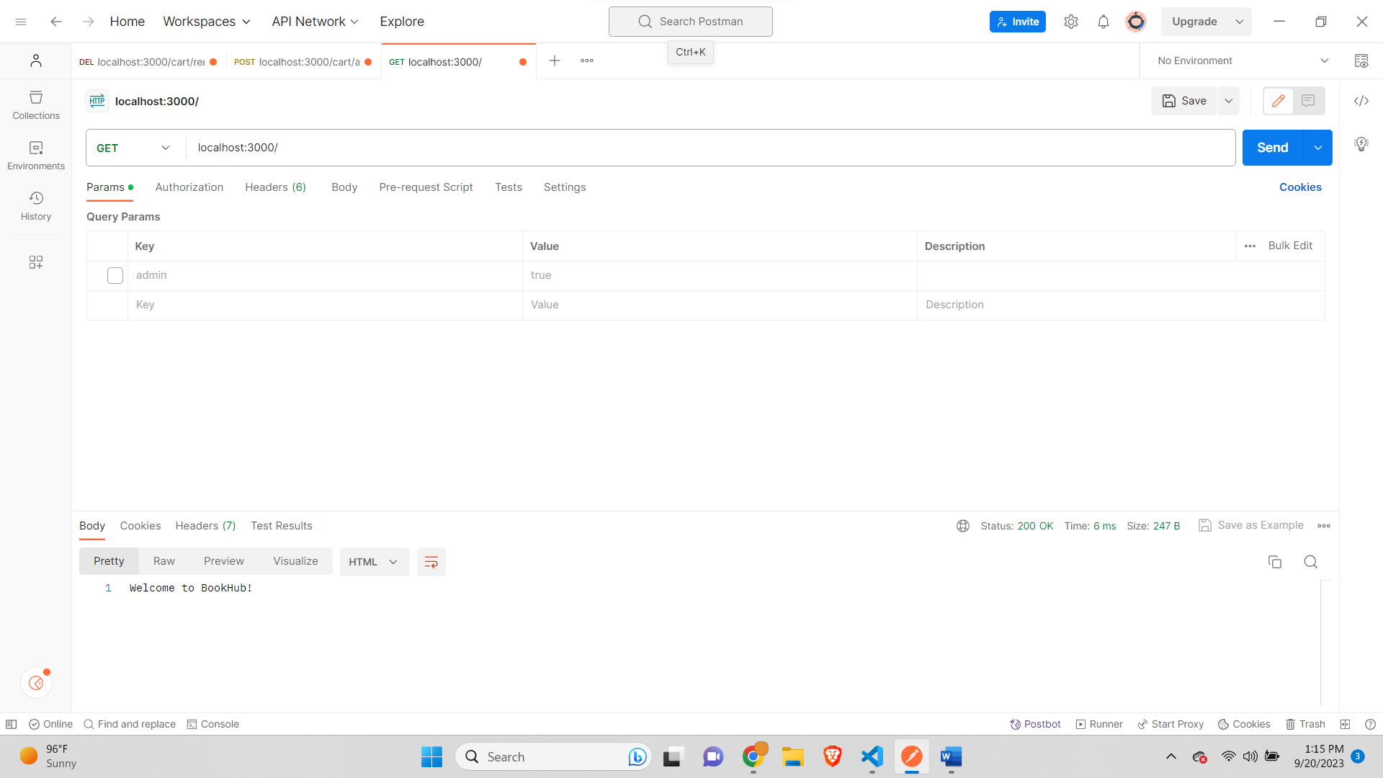

**Add Book route with admin true-**

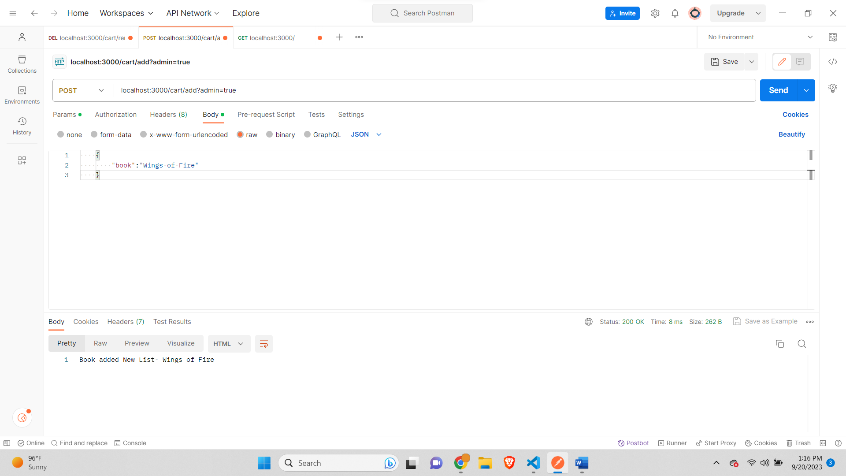

**Add Book with no admin-**

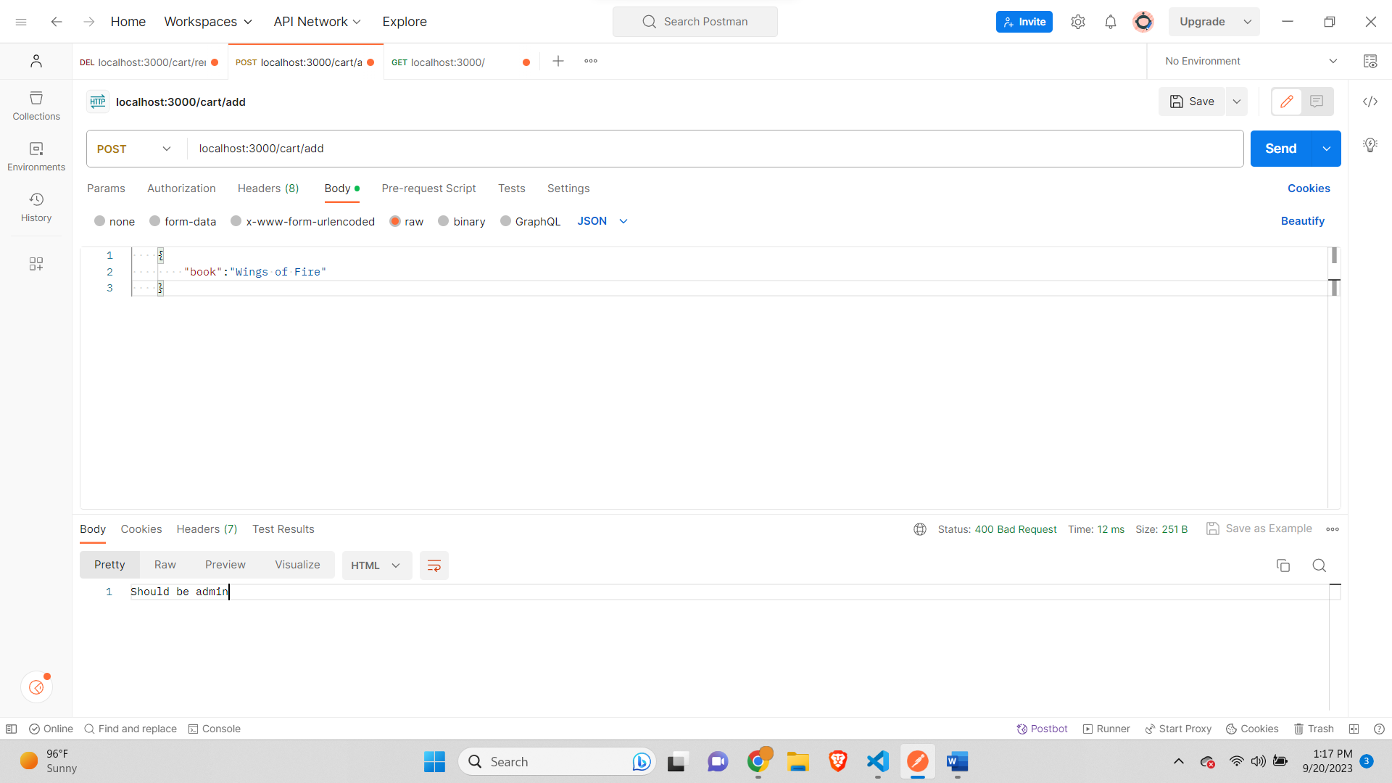

**All Books added-**

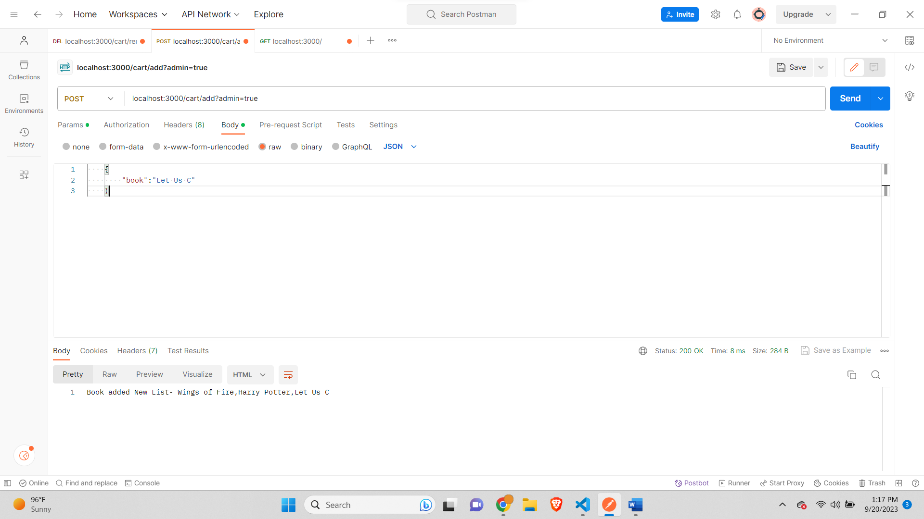

**Delete book out of Index-**

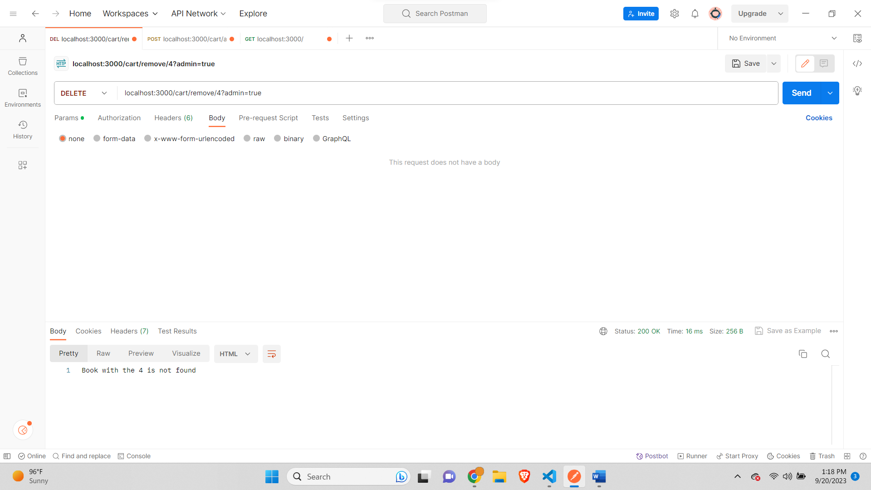

**Delete book with proper Index-**

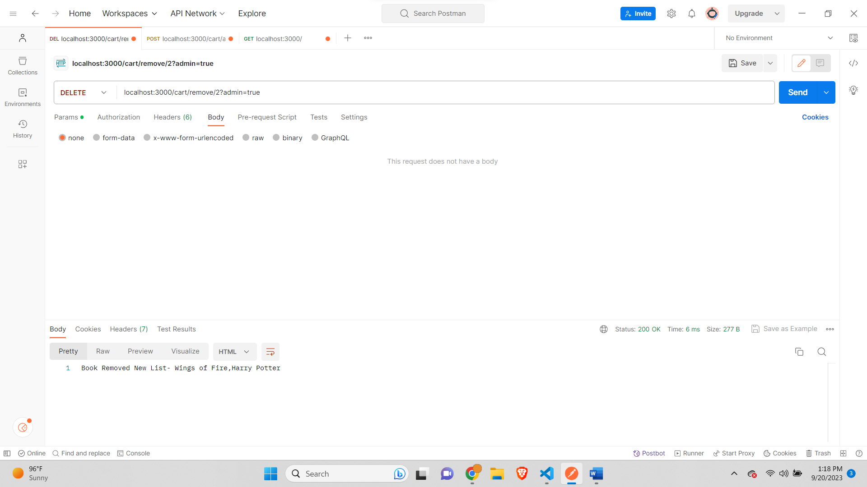

**Delete book with no admin-**

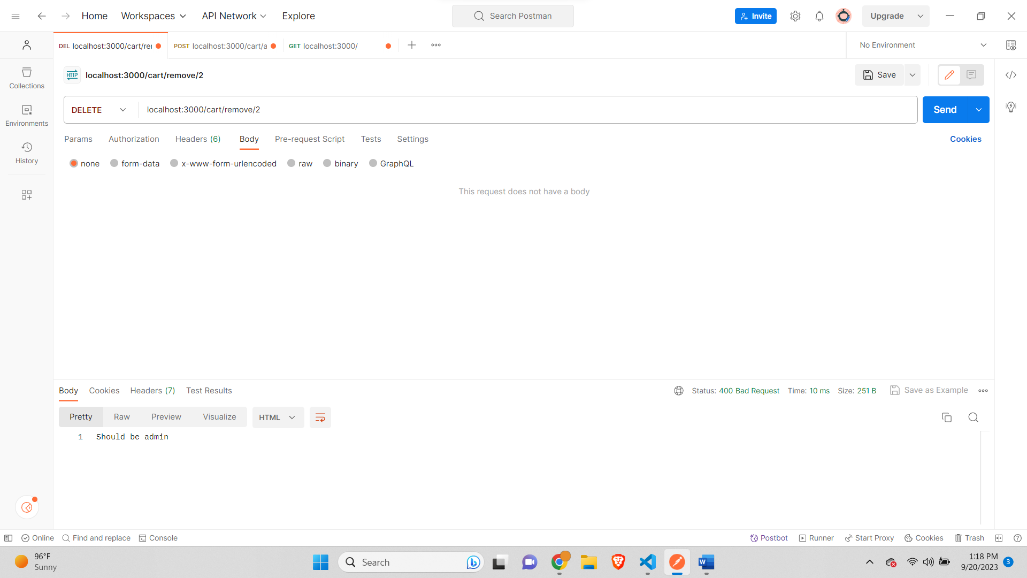

**Part C:**

**Get Home-**

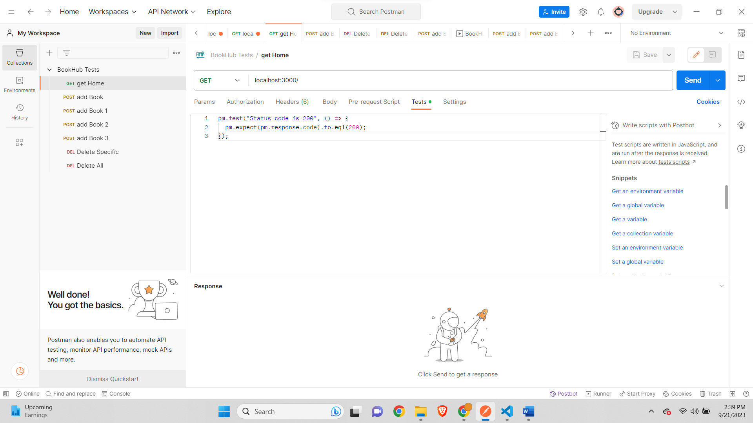

**POST add Book-**

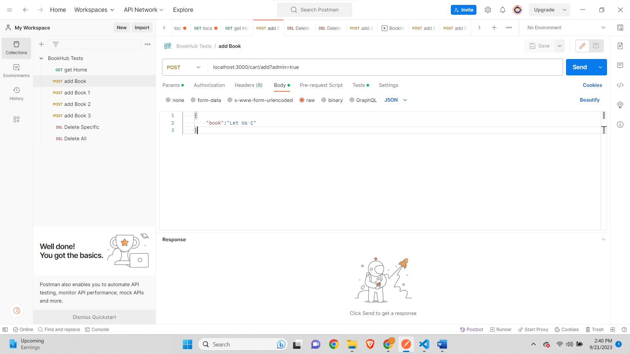

**POST add Book 1-**

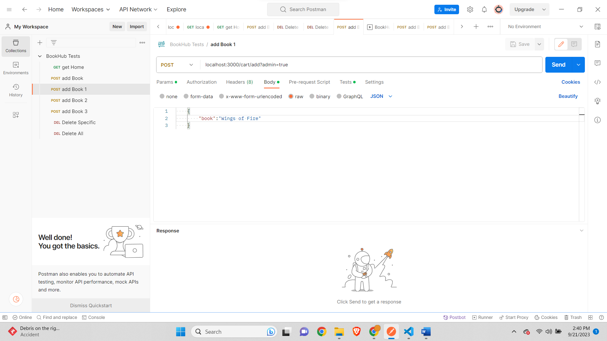

**POST add Book 2-**

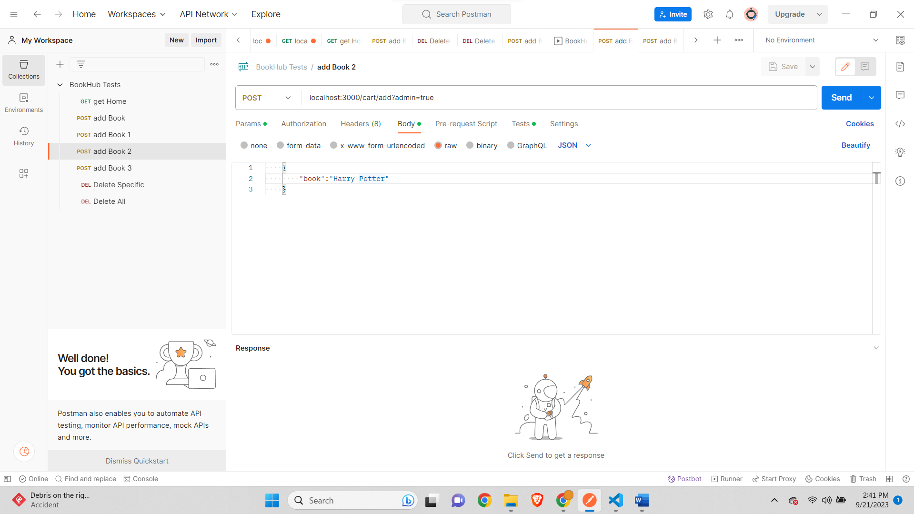

**POST add Book 3-**

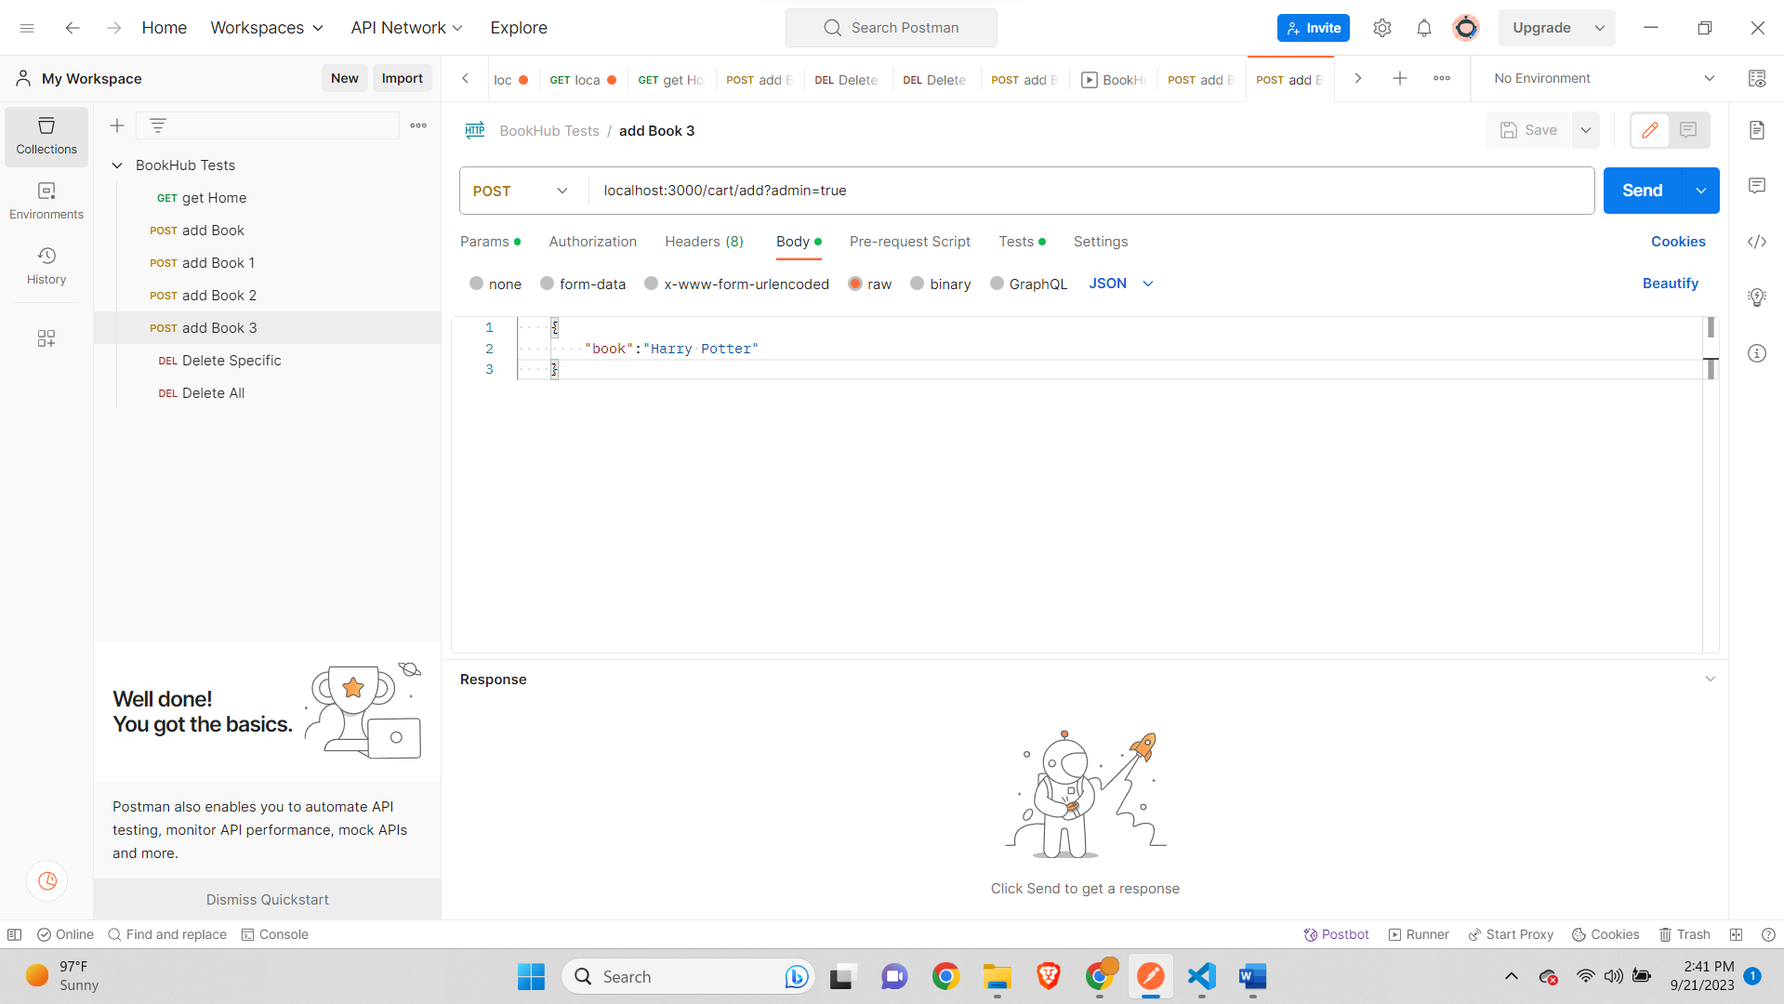

**DELETE Delete Specific-**

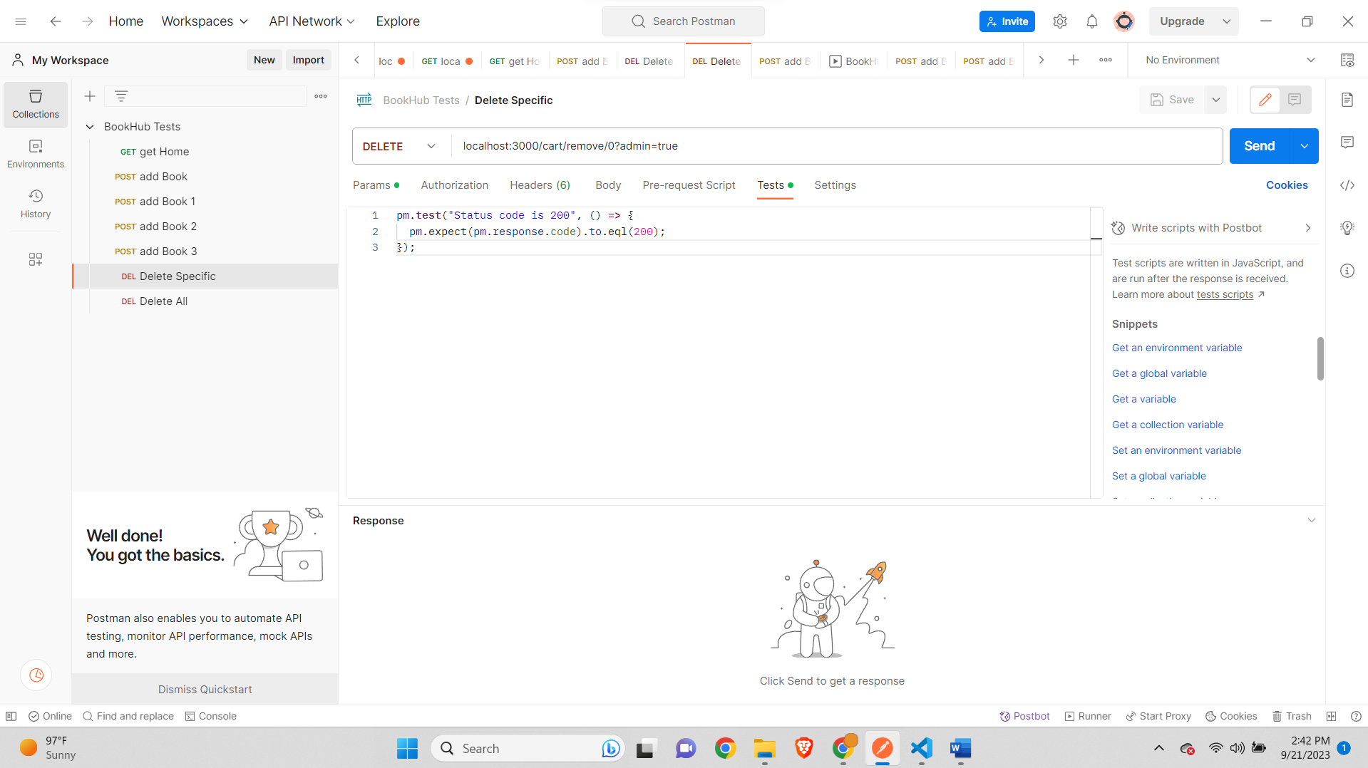

**Delete Delete All-**

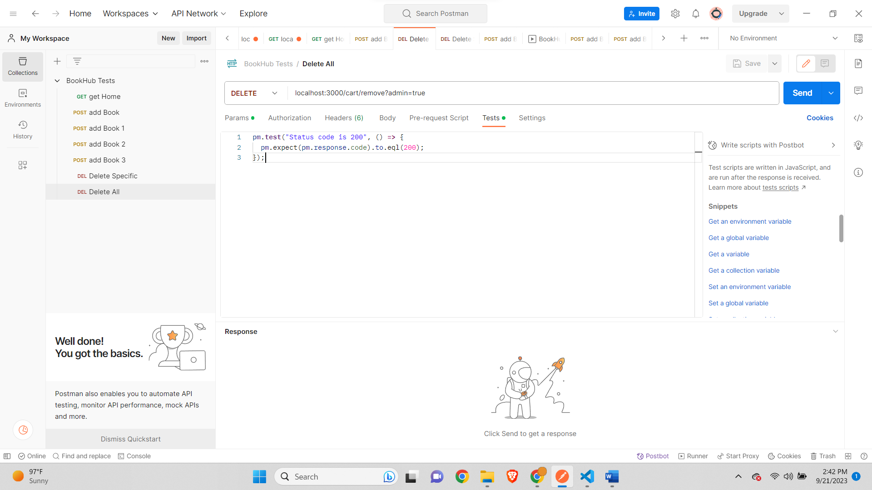

**Run Results-**

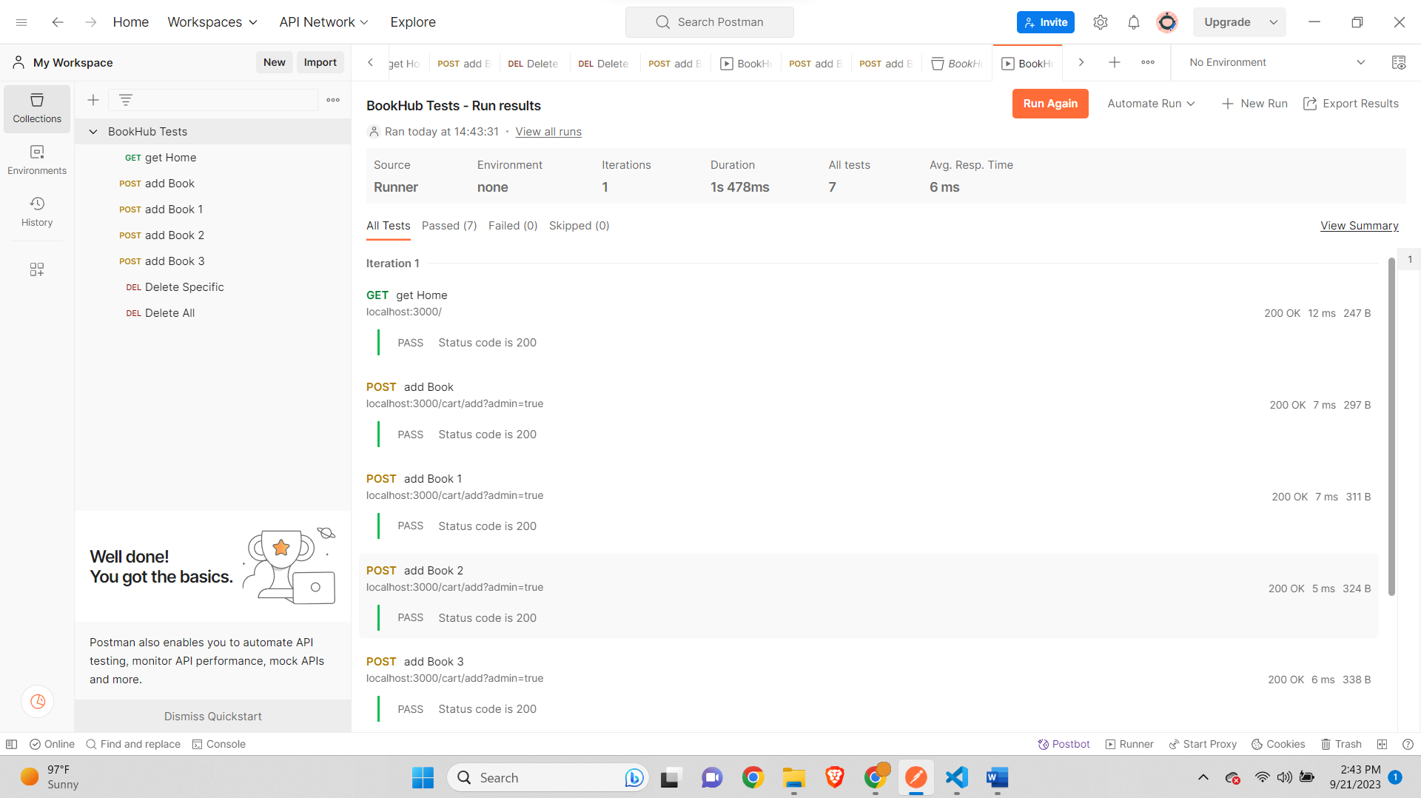

**Remaining Test Results-**

